Year 1 Spring Term - January 2024 - Our Learning
English | Maths
- Daily phonics lessons for all children, which includes reading (Sounds, words, sentences and books), writing and spelling.  - Class books: ‘Zog’ and ‘Cops and Robbers’.  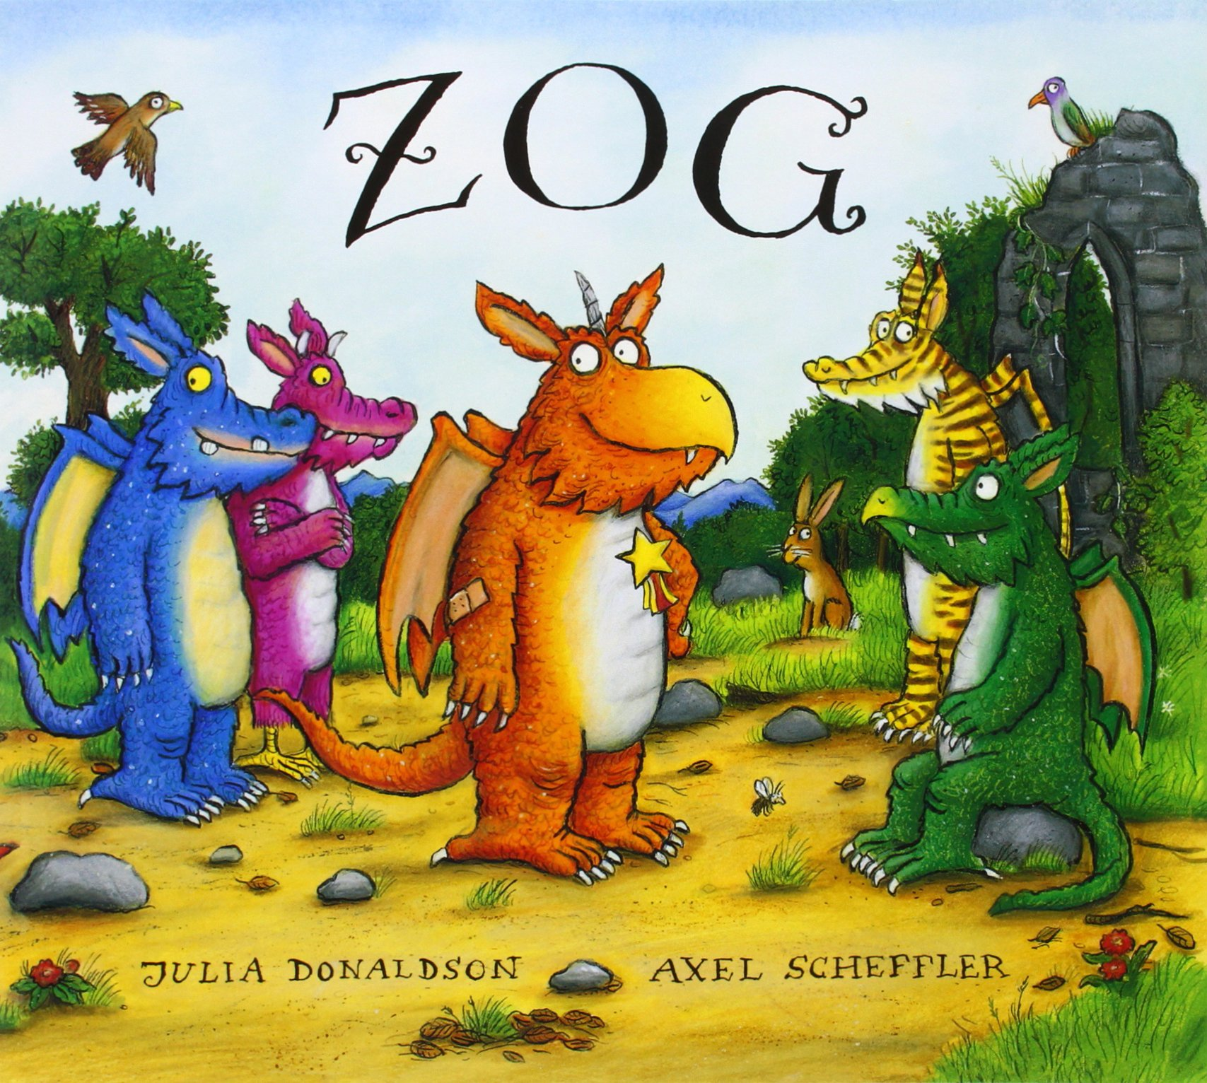  - Weekly activities across the curriculum will be inspired by our class books.  - Create my own sentence - build it in my  head, rehearse it, remember it and  write it using my phonics to help me spell.  - Use capital letters and full stops. | - Numbers to 20 - counting, writing, ordering and comparing numbers.  - Addition and Subtraction withing 20 - add by making ten, adding/subtracting ones, subtracting by counting back.  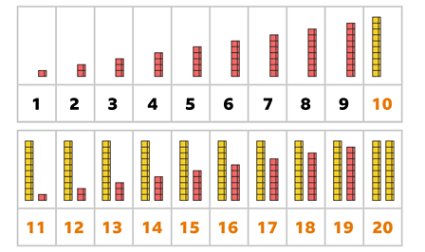
How you can help at home: | How you can help at home:
- Read with your child every day. Your child can read their school reading book to you using their phonic skills to work out new words. Encourage them to read familiar words quickly and fluently, and chat about the story together to check understanding.  - Read aloud to your child using the library book sent home from school or any other books your child enjoys. There are lots of free ebooks online and membership of March library is free as well. | Practise maths skills through everyday tasks such as:  - Counting objects, including by grouping into 2s, 5s and 10s  - Money - recognising the value of each type of coin and counting up the value of a small pile of coins  - Using digital and analogue clocks to tell the time - o’clocks, half past, quarter to and quarter past  - Cooking or baking together - using scales to weight the ingredients  - Naming 2D and 3D shapes you can see in the world around you. Which ones are symmetrical?

Science | History | Geography | Art and Design | Design Technology | Music | P.E. | P.S.H.E. | Computing | R.E.
Describing, comparing and classifying materials  Exploring soft materials for toys  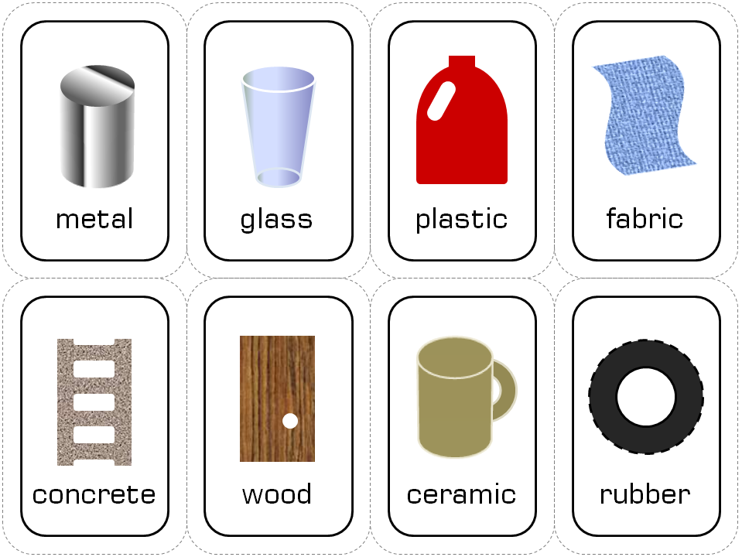 | Exploring different toys for babies, toddlers and children  Comparing modern toys and old toys looking at similarities and differences | Geography will be covered in Spring 2. | Drawing a toy using pastels to build up pattern and texture  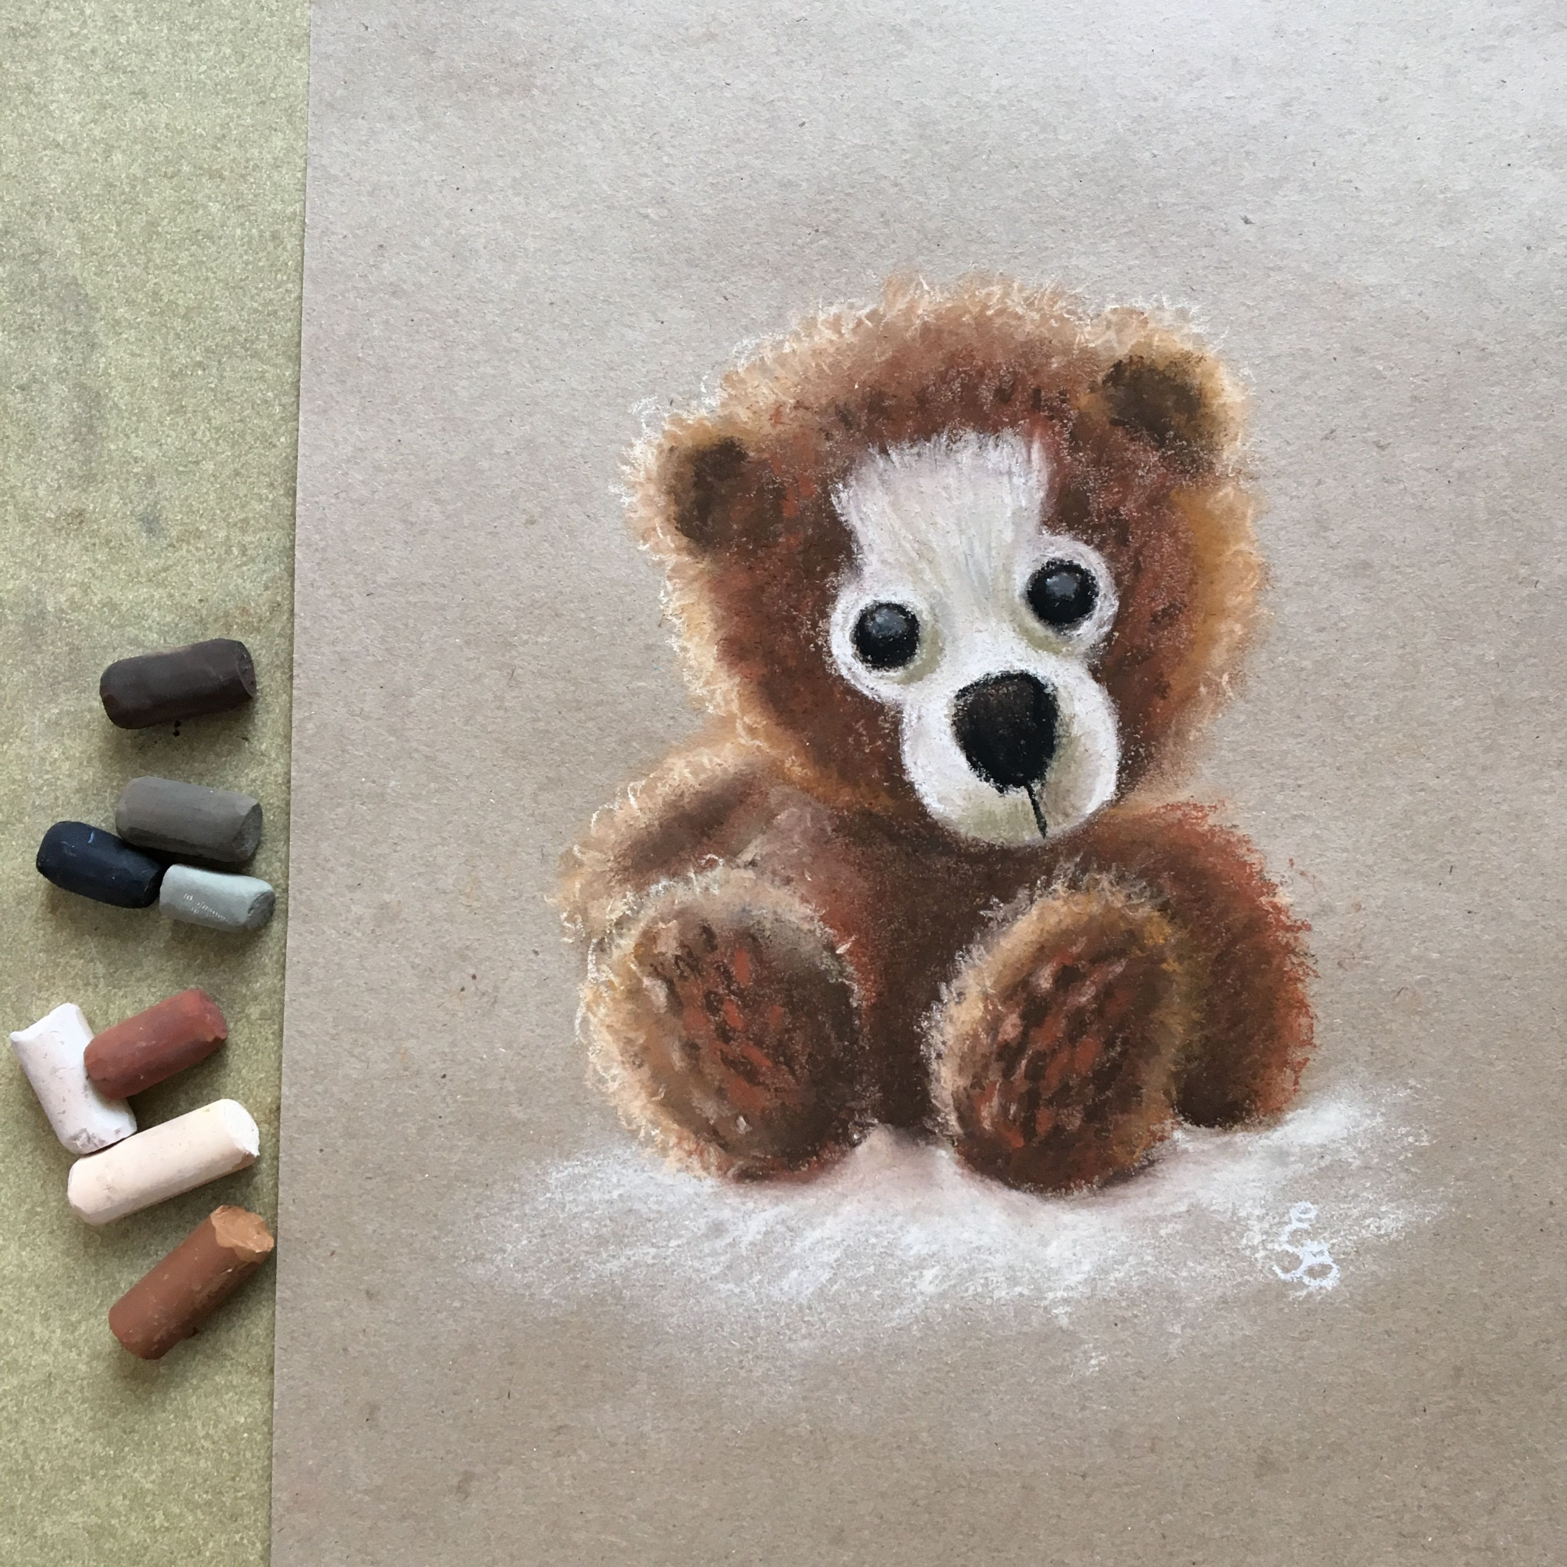  Printing with objects | Design technology will be covered in Spring 2 | Create sound effects for stories and images  Learn to use your voice expressively and creatively by singing songs and speaking chants and rhymes. | Exploring seated static balance  Exploring dynamic balance on a line and in a stance  Comparing movements with others | Exploring my identity - What makes me ‘me and what makes you ‘you’?  To value differences by recognising different groups they belong to and different backgrounds of people they know | Computing will be covered in Spring 2 | Identifying differences does belonging to a faith make to a family  Understanding why God and Jesus is important to Christian people  Understanding how Sunday worship increases faith in Christian families

