Year 3 Spring Term B - February and March

English | Maths
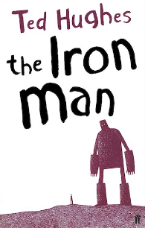  Class Book: The Iron Man by Ted Hughes  - Learning about the features of newspapers and writing newspaper reports.  - Continuing to build and use our knowledge of grammar, including conjunctions, adverbs and prepositions. Further practice of using paragraphs and inverted commas.  - Learning to spell further prefixes and homophones, as well as words which use the ‘ough’ letter pattern.  - Celebrating reading through various activities during Book Week. | Money  - Adding and subtracting amounts of money to give change, using both £ and p in practical contexts.  Time  - Telling and writing the time to the nearest minute.  Pictograms  - Learning to create and interpret pictograms and bar graphs.  Fractions  - Recognising and using fractions as numbers.  - Adding and subtracting fractions.
How you can help at home: | How you can help at home:
- Read with your child, even if they are a fluent and confident reader, asking comprehension questions; there are example questions to guide you in the Y3 google classroom.  - Encourage your child to read independently for sustained periods  - Learn weekly spellings - use the booklet sent home to practise them every day. You can also find these in the google classroom.  - Complete spelling homework in the Y3 google classroom by Friday each week. | - Practise rapid recall of times tables and linked division facts with a focus on the 4s,8s and 3s up to 12x.  - Encourage your child to use TT Rock Stars.  - Use opportunities to practise using money and calculating change in daily life.  - Use opportunities to tell the time in daily life.  - You will find a summary of the written calculation methods we teach in school in the Y3 google classroom.

Science | History | Geography | Art and Design | Design Technology | Music | P.E | PSHE | Computing | Spanish | RE
Light  Recognising that we need light to see things and dark is the absence of light.  Learning that light is reflected from surfaces.  Recognising that light from the sun is dangerous and there are ways to protect our eyes.  Recognising that shadows are formed when light is blocked by a solid object. | Taught in Spring A | Where we live  Where is our locality in relation to other places?  Where is our school? Where do you live?  Can you describe your journey to school?  What is our town like?  How do features of the local area influence human activity?  What changes have taken place to our local area? What was Fenland like in the past? | Taught in Spring A | To design, make and evaluate a ‘moving animal in a box’ toy for small children.  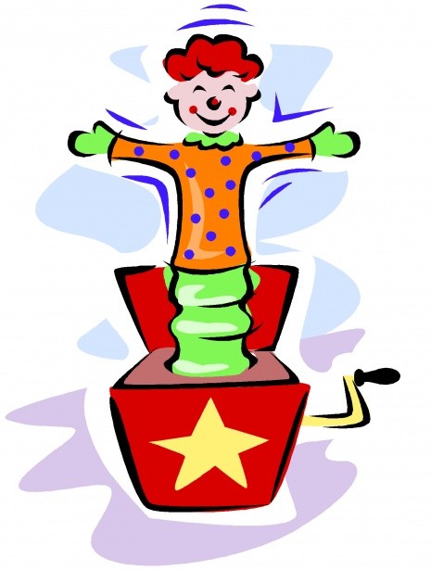 | How can rhymes be described through rhythmic symbols?  Why do we repeat patterns in music?  To compose music using rhythmic ostinati based on a spoken phrase.  To keep a steady tempo throughout music. | Swimming  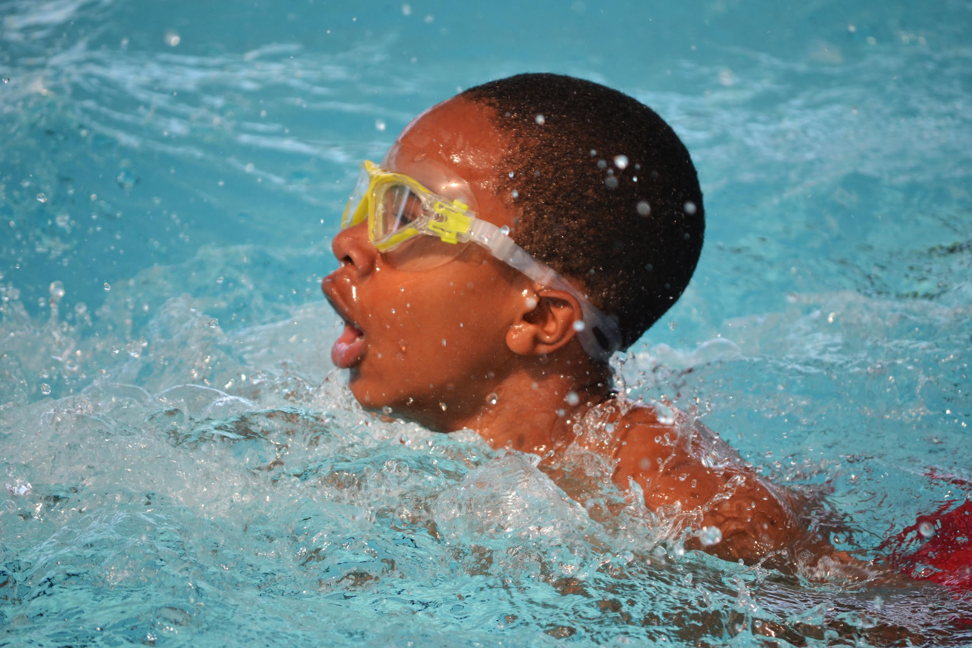  Gaining confidence and introducing front and back strokes  Hockey  Developing control learning new skills | Sex and Relationships Education  How are male and female bodies different?  What can my body do and how is it special?  Why is it important to keep clean?  How can I prevent illness and disease? |  | Learning numbers up to 15.  Asking ‘how many?’  Asking ‘where do you live?’ | Special religious texts  What makes something sacred?  Why is the Bible important for Christians?  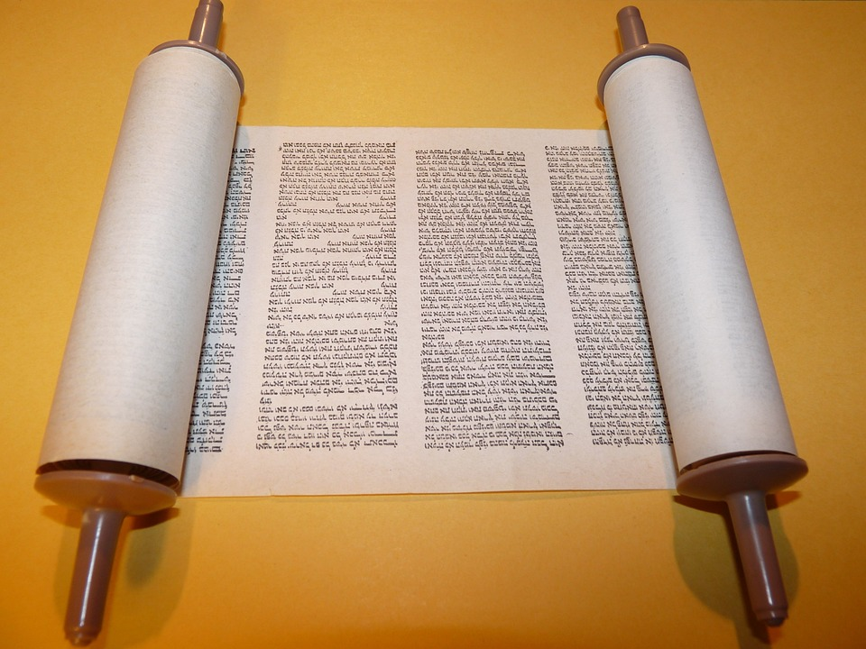  Why is the Torah important for Jewish people?  Why is the Qur’an important for Muslims?

