Year 6 Spring Term A - Our Learning

English | Maths
- We will be using the visual text ‘Pandora’ to write a persuasive holiday brochure.  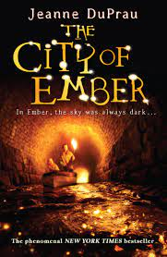  - The class will begin reading ‘City of Ember’ and focus their writing skills on narrative and dialogue.  - We will continue to develop our grammar and spelling skills in daily lessons.  - Reading comprehension skills  - Using a wide range of punctuation marks  - accurately in our writing  - English homework will be set on Friday’s using the Google Classroom. Please let us know if you need a paper copy. | - Pupils will be exploring how to calculate the percentage of numbers and quantities.  - Pupils will be exploring how to calculate the area of rectangles, triangles and parallelograms.  - Pupils will learn to present and interpret information in different ways.  - Pupils will continue to develop their arithmetic and reasoning skills to support Year 6 maths.
How you can help at home: | How you can help at home:
- Read with your child, even if they are a fluent and confident reader, asking comprehension questions; there are example questions to guide you in the Y6 google classroom  - Encourage your child to read independently for sustained periods  - Learn weekly spellings (these are set as homework in the Y6 google classroom | - Encourage your child to complete weekly homework - Mathletics tasks set weekly on Fridays  - Practise rapid recall of times tables and linked division facts  - Use opportunities to tell the time in daily life  - You will find a summary of the written calculation methods we teach in school in the Y6 google classroom.

Science | History | Geography | Art and Design | Design Technology | Music | P.E and Games | PSHE | Computing | Spanish | RE
The Earth  This term the children will learn about our Solar System and how we get night and day.  They will learn about the moon and seasons.  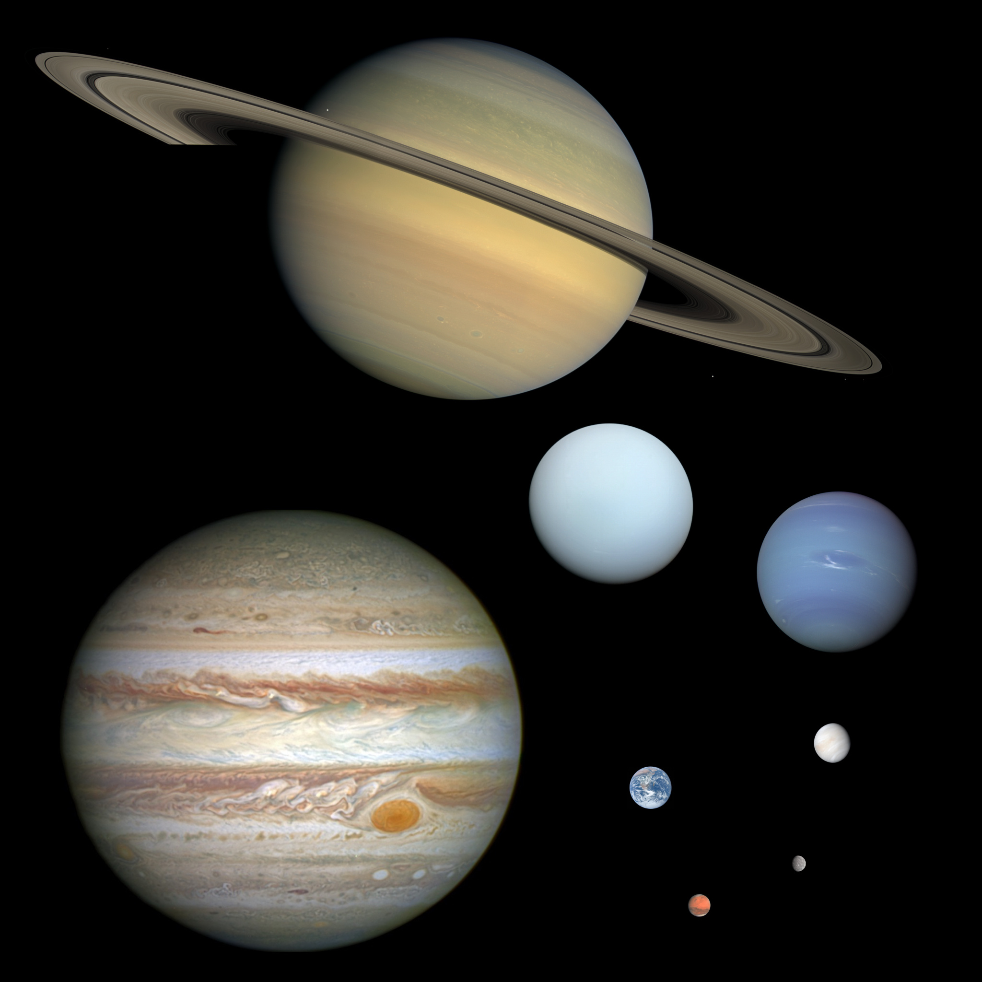 | The Tudors  This term the children will learn about the Tudor dynasty including Elizabeth I and about Tudor explorers.  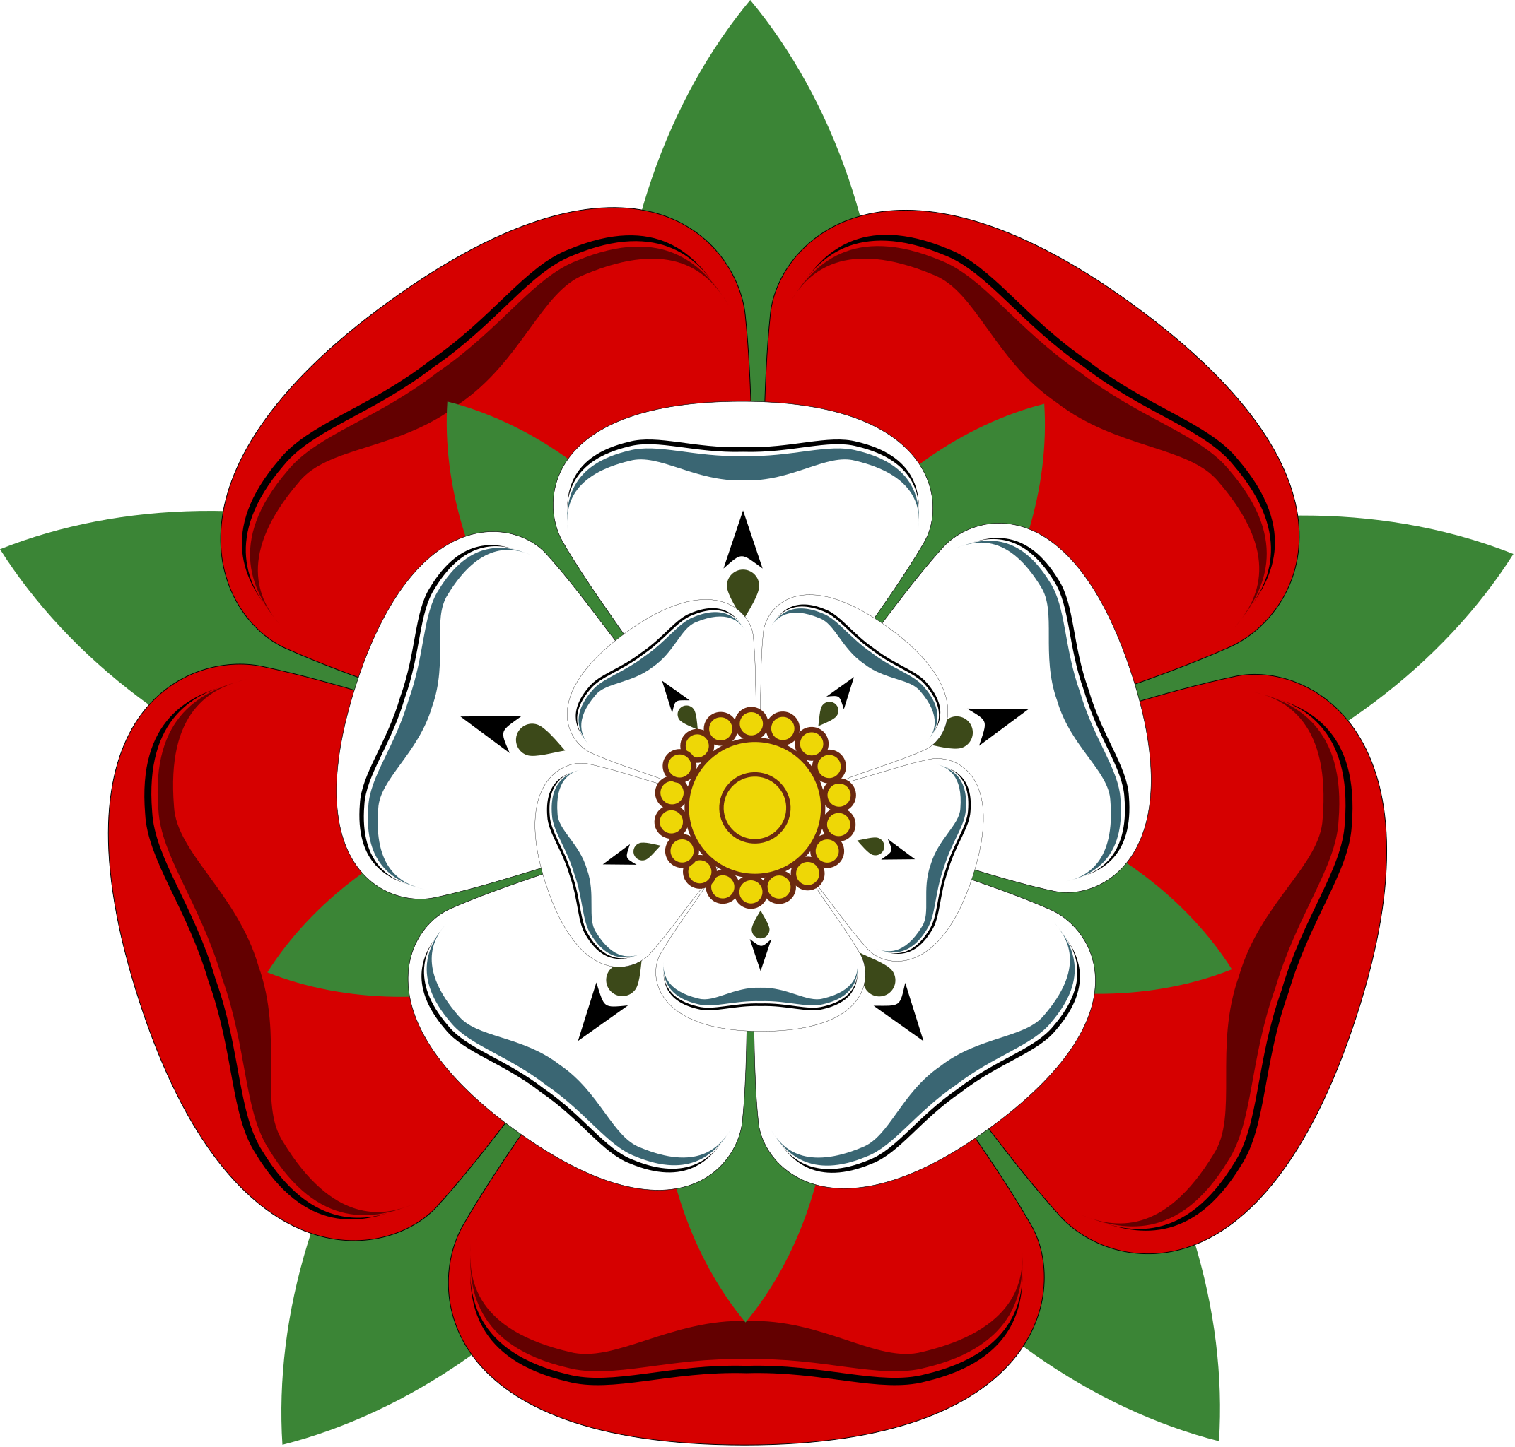 | This will be taught next half term | Tudors  Learn about and sketch Tudor miniatures using their portraits.  Collage and design Coat of arms.  The use of - ipad art programs to create Tudor pictures.  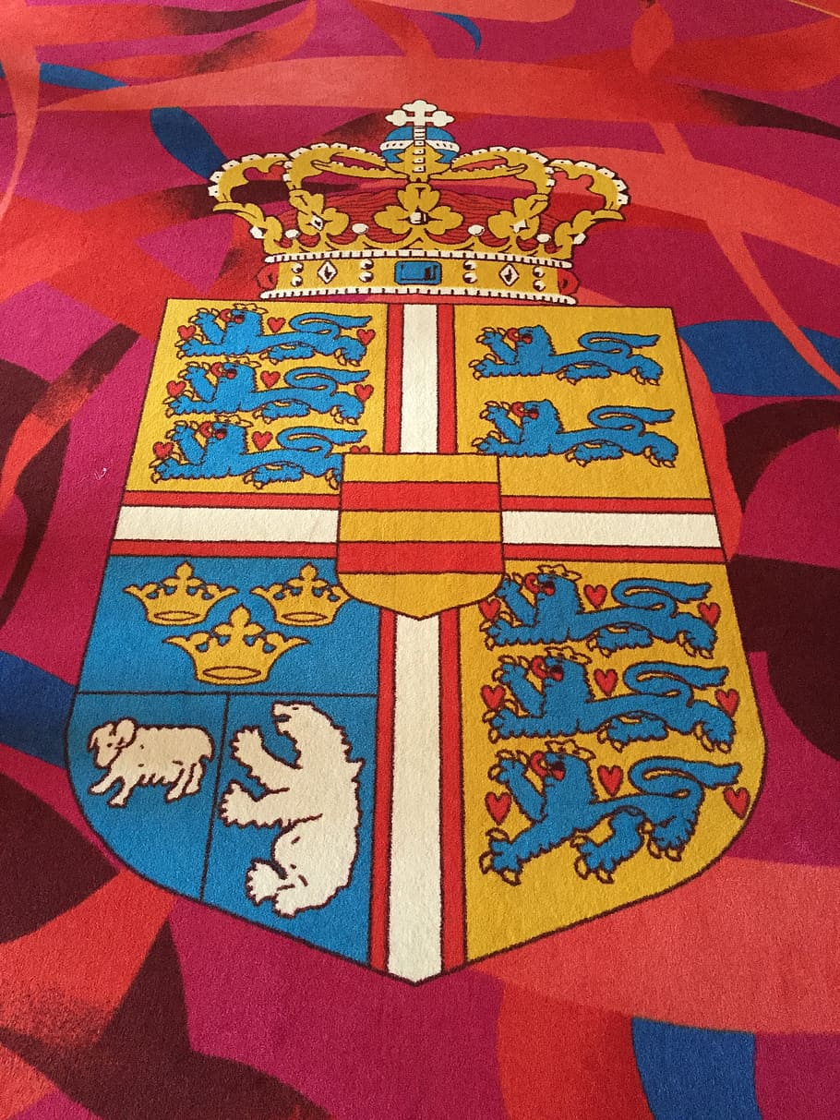 | Space Toy  The children will be designing and making a space toy for a younger child from felt.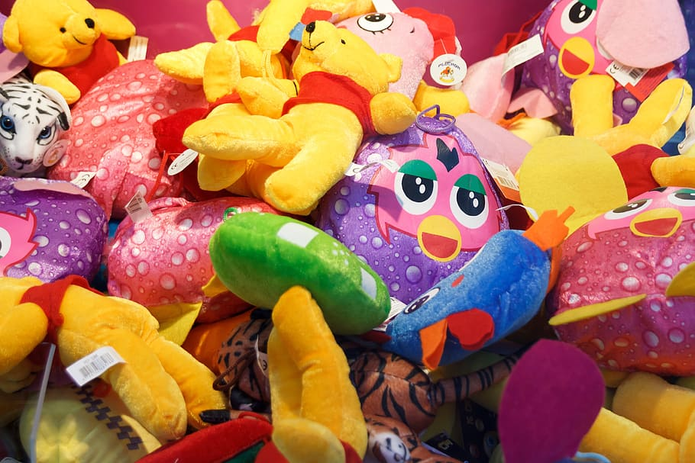. | This will be taught next half term | Dance - Master dance skills considering 'personal' objectives.  Games - Netball - to apply skills needed in netball (passing, defending and attacking) to impact competitive games.  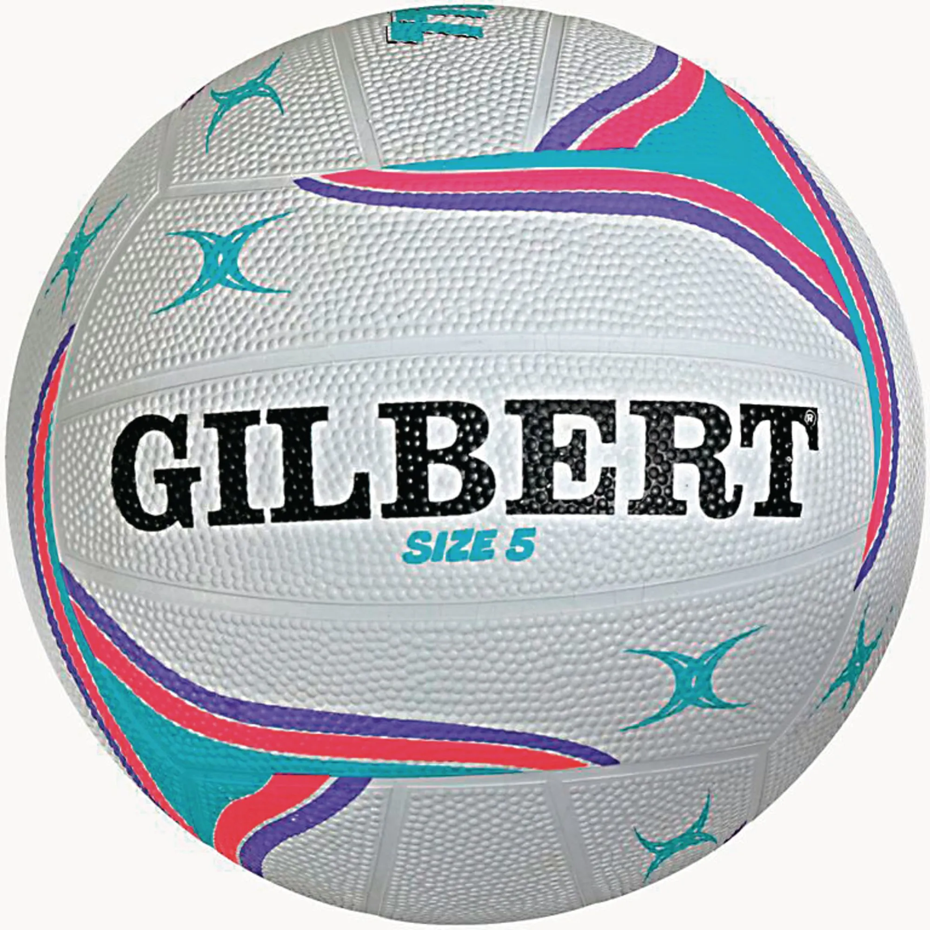 | Healthy friendships  Explain the characteristics of friendships online and offline. Understand what makes a healthy and unhealthy friendship.  Explore concepts of trust and loyalty. | Spreadsheets  Children will be supported in organising data into columns and rows to create their own data set.  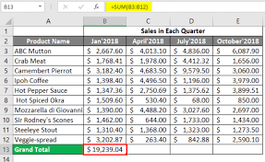 | Planets  This half term children will learn about the planets describing them by their colour, size and temperature.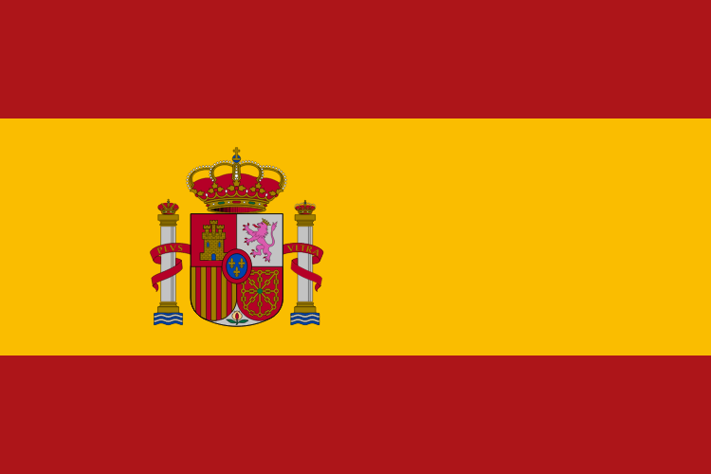 | What happens when we die?  We will be thinking about heaven, discussing ideas about ‘souls’ and types of funerals.  