Year 6 Spring Term 1 - January and February 2024 - Our Learning

English | Maths
- We will be using the visual text ‘Pandora’ to write a persuasive holiday brochure.  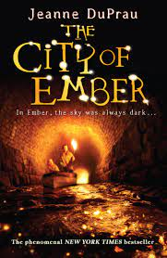  - The class will begin reading ‘City of Ember’ and focus their writing skills on narrative and dialogue.  - We will continue to develop our grammar and spelling skills in daily lessons.  - Reading comprehension skills  - Using a wide range of punctuation marks  - accurately in our writing | - Pupils will be exploring how to calculate the percentage of numbers and quantities.  - Pupils will be exploring how to calculate the area of rectangles, triangles and parallelograms.  - Pupils will learn to present and interpret information in different ways.  - Pupils will continue to develop their arithmetic and reasoning skills to support Year 6 maths.
How you can help at home: | How you can help at home:
- Read with your child, even if they are a fluent and confident reader, asking comprehension questions; there are example questions to guide you in the Y6 google classroom  - Encourage your child to read independently for sustained periods  - Learn weekly spellings (these are set as homework in the Y6 google classroom) | - Encourage your child to complete weekly homework - SATS Companion tasks set weekly on Fridays  - Practise rapid recall of times tables and linked division facts. TT Rockstars homework is set each week  - Use opportunities to tell the time in daily life

Science | History | Geography | Art and Design | Design Technology | Music | P.E and Games | PSHE | Computing | Spanish | RE
The Earth  This term the children will learn about our Solar System and how we get night and day.  They will learn about the moon and seasons.  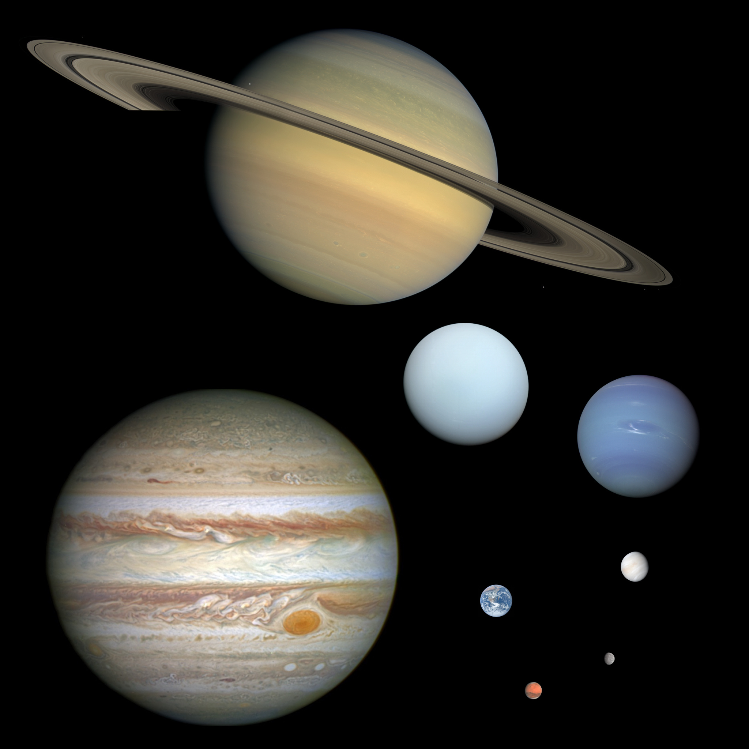 | This will be taught next half term. | Northern France  Locating France on world and continental maps.  Comparison between St Michael’s Mount and Le Mont St. Michel.  Explore Normandy. | Tudors  Learn about and sketch Tudor miniatures using their portraits.  Print Tudor armour using the skill of monoprinting.  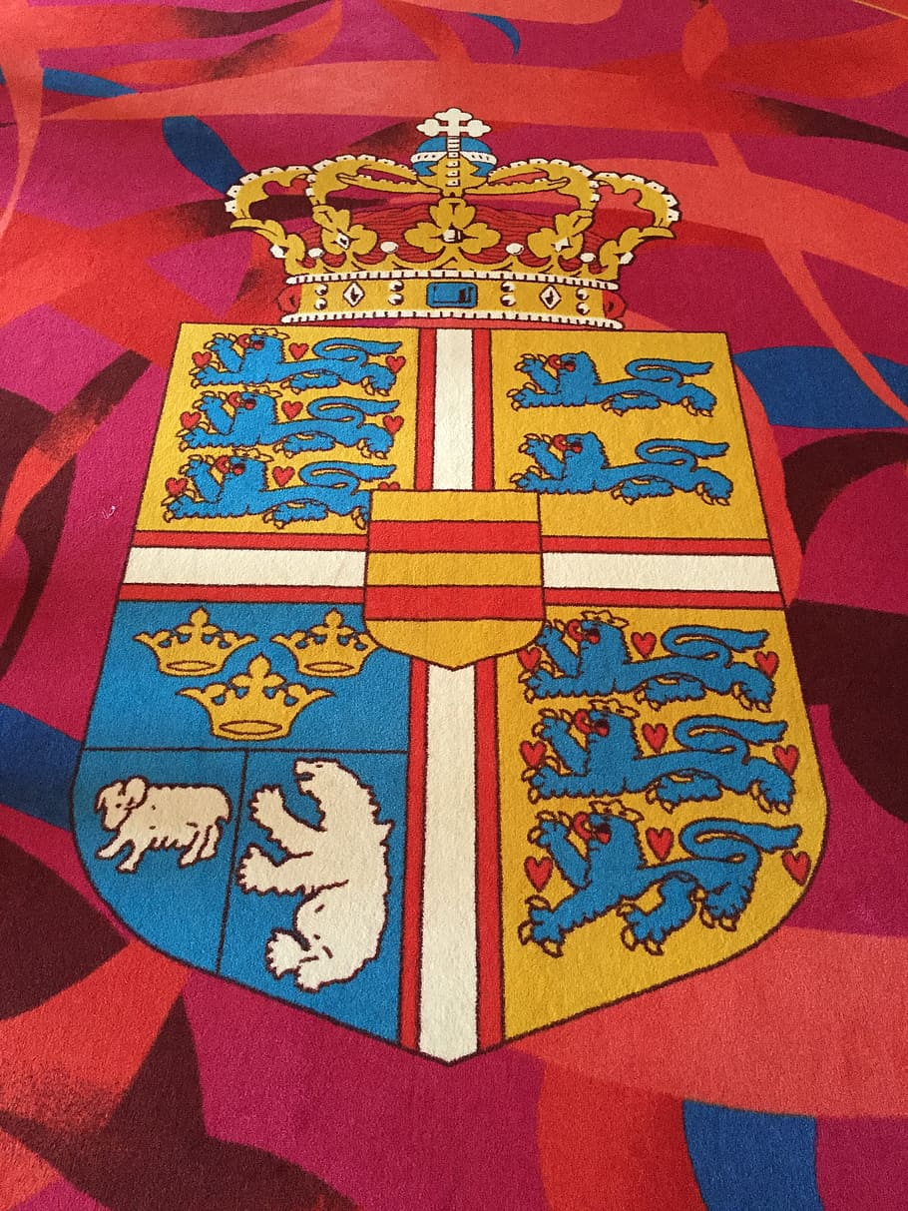 | Space Toy  The children will be designing and making a space toy for a younger child from felt.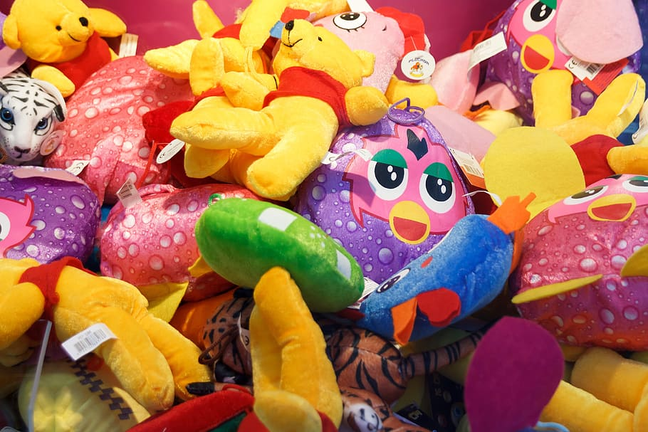. | This will be taught next half term | Dance - Master dance skills considering 'personal' objectives.  Games - Netball - to apply skills needed in netball (passing, defending and attacking) to impact competitive games. | Healthy friendships  Explain the characteristics of friendships online and offline. Understand what makes a healthy and unhealthy friendship.  Explore concepts of trust and loyalty. | Spreadsheets  Children will be supported in organising data into columns and rows to create their own data set.  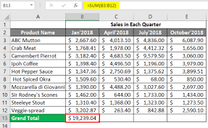 | Sports  We will be learning how to say different sports in Spanish and learn how to explain when we practise them.  In the Town  We will be learning how to have a conversation about where we live, the buildings that are there. | What happens when we die?  We will be thinking about heaven, discussing ideas about ‘souls’ and types of funerals.

