Year 2 Spring Term B - Our Learning

English | Maths
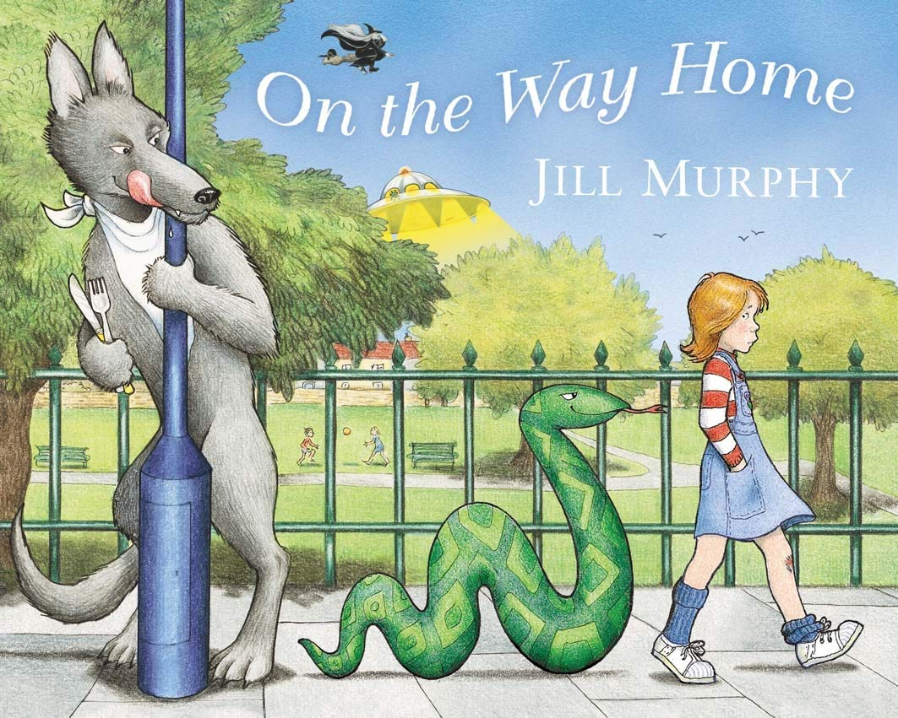  - Class text - On the Way Home - we will be writing our own version of the story, changing the characters and creatures that we encounter on our way home!  - To link with our geography, we will be writing in role as Katie Morag - using a letter to compare the fictional Isle of Struay with our own town, March.  - We will be continuing our weekly handwriting sessions and phonics lessons. | 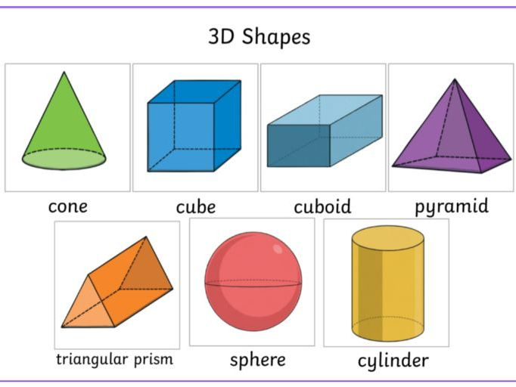  - 2D shapes - recognising, naming and drawing.  - 3D shapes - recognising, describing and grouping.  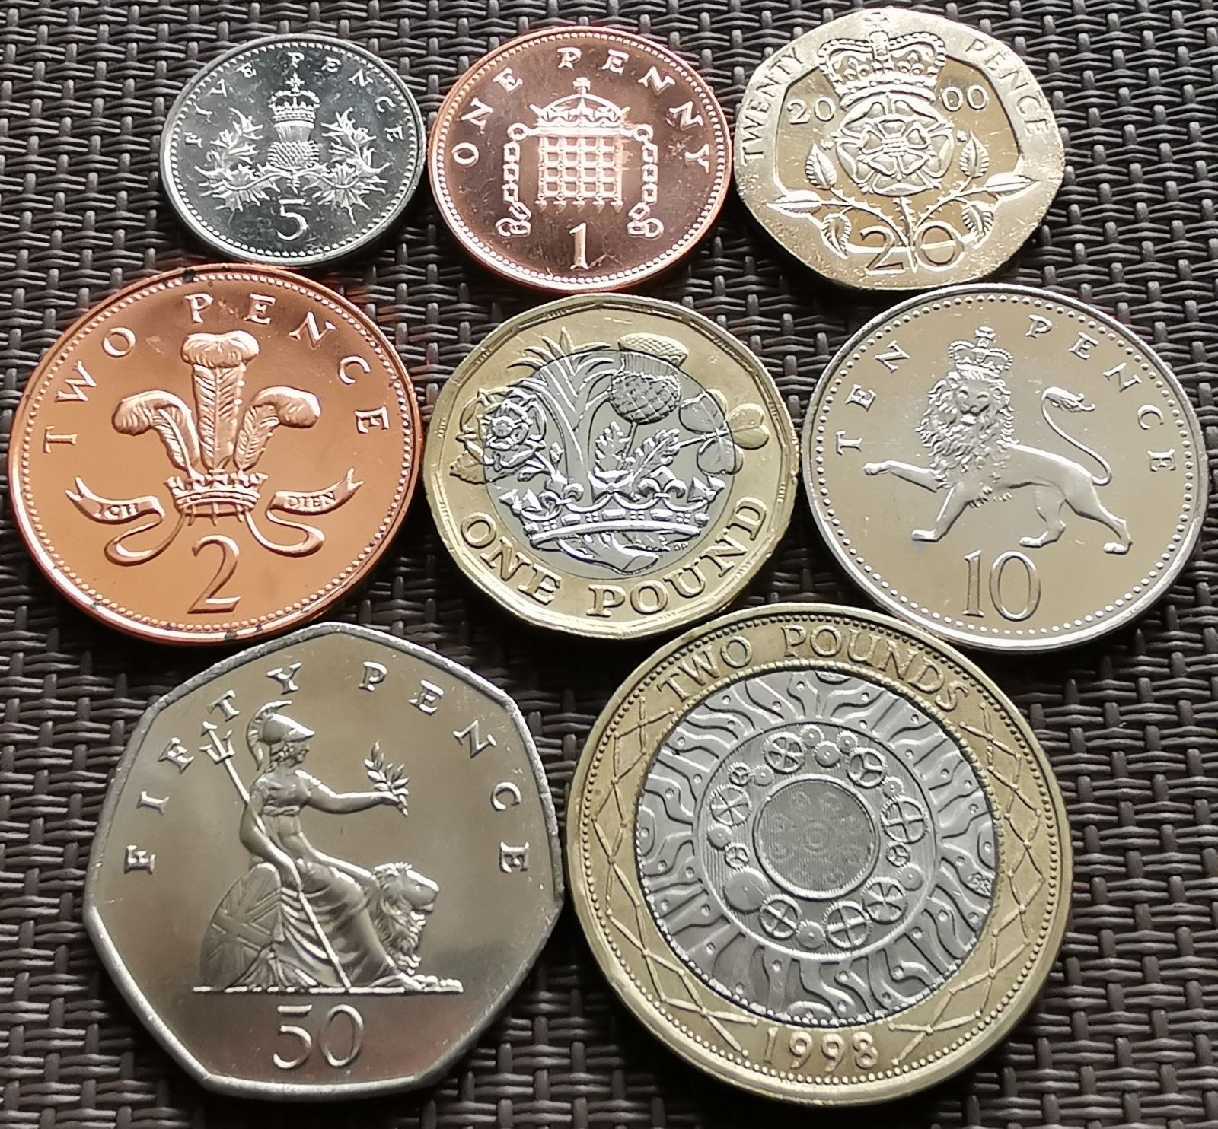  - Money - representing amounts using £ and p.
How you can help at home: | How you can help at home:
- Read with your child every day. Your child can read their school reading book to you using their phonic skills to work out new words. Encourage them to read familiar words quickly and fluently, and chat about the story together to check understanding.  - Read aloud to your child using the library book sent home from school or any other books your child enjoys. There are lots of free ebooks online and membership of the March library is free as well. | Practise maths skills through everyday tasks such as:  - Counting objects, including by grouping into 2s, 5s and 10s  - Money - recognising the value of each type of coin and counting up the value of a small pile of coins  - Using digital and analogue clocks to tell the time - o’clocks, half past, quarter to and quarter past  - Cooking or baking together - using scales to weight the ingredients  - Naming 2D and 3D shapes you can see in the world around you. Which ones are symmetrical?

Science | History | Geography | Art and Design | Design Technology | Music | P.E. | P.S.H.E. | Computing | R.E.
Materials:  What are the different properties of materials?  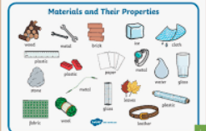 | Homes:  Visit to the March Museum. Can you identify objects from the past?  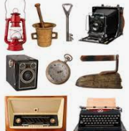 | Katie Morag:  Can you identify the human and physical features on the Isle of Struay?  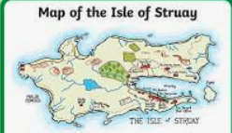 | Covered later in term. | Make:  Can you create your placemat using fabric and different stitches?  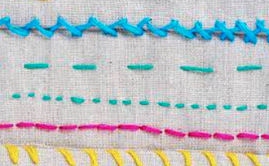 | Recognise and explore different sound choices.  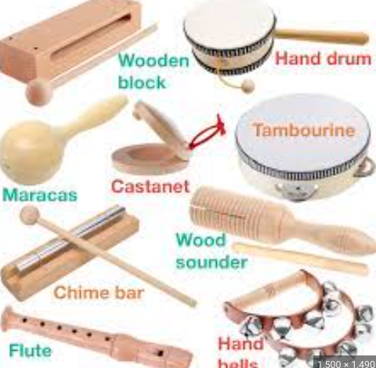 | Ball skills:  Sending and receiving the ball in multiple ways.  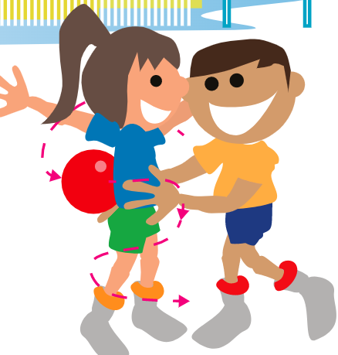 | Family and friends:  How do we care for each other? Why is it important to tell the truth?  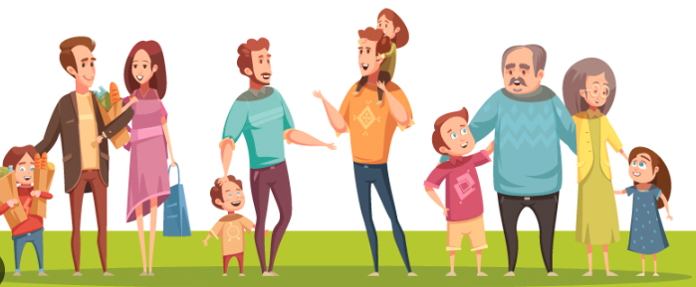 | Pictograms:  Create a pictogram using the Chromebook. | Sikhism  How do the stories from the Gurus affect Sikh children?

