Year 4 Spring Term A - January and February - Our Learning

English | Maths
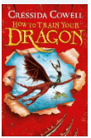  - In English, our class reader for this term is  How to Train Your Dragon by Cressida Cowell.  - We will be using this book to help us learn how  to write effective and detailed recounts.  - After recounts, we will focus on narrative writing.  We will write our own Viking stories after reading  Viking myths and legends. | - In Maths this term, Year 4 will continue to develop their multiplication and division skills, applying times tables to more complex questions.  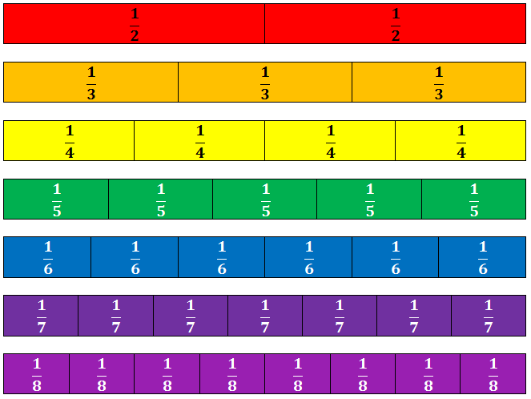  - We will then look at reading, interpreting and drawing a range of graphs before beginning to think about fractions.  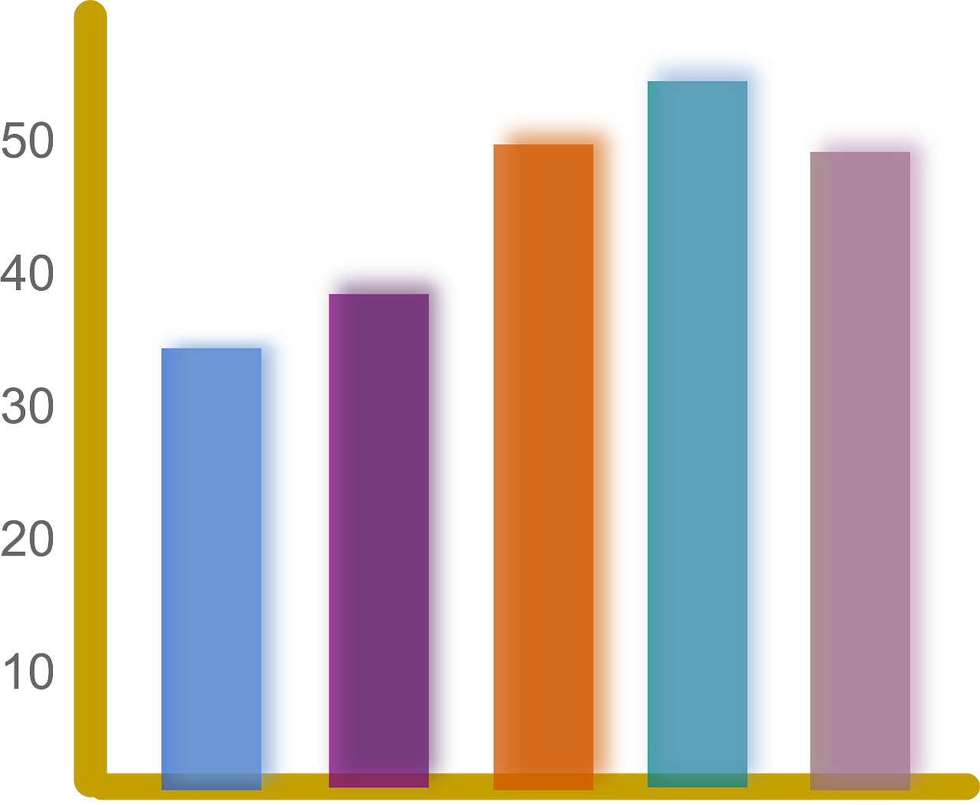
How you can help at home: | How you can help at home:
- Read with your child, even if they are a fluent and confident reader, asking comprehension questions; there are example questions to guide you in the Y5 google classroom  - Encourage your child to read independently for sustained periods  - Learn weekly spellings (these are set as homework in the Y4 google classroom) | - Encourage your child to complete weekly homework - Mathletics tasks set weekly on Fridays  - Practise rapid recall of times tables and linked division facts - this is even more key as the MTC times table check approaches.  - Use opportunities to tell the time in daily life  - You will find a summary of the written calculation methods we teach in school in the Y4 google classroom.

Science | History | Geography | Art and Design | Design Technology | Music | P.E | PSHE | Computing | Spanish | RE
Dangers to living things  What are food chains and why are they important?  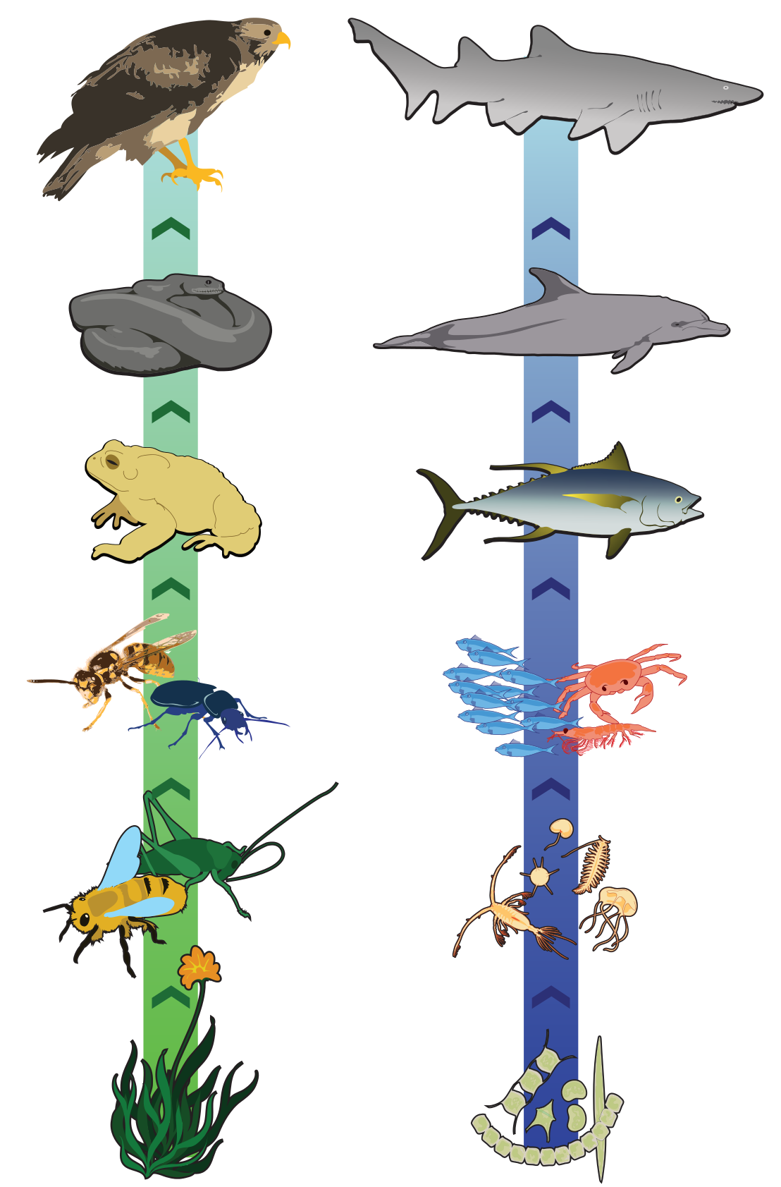  How do changes to an environment affect the animals that live there? | Water, Ships and Seafarers  Who were the Anglo-Saxons and Vikings and where did they come from?  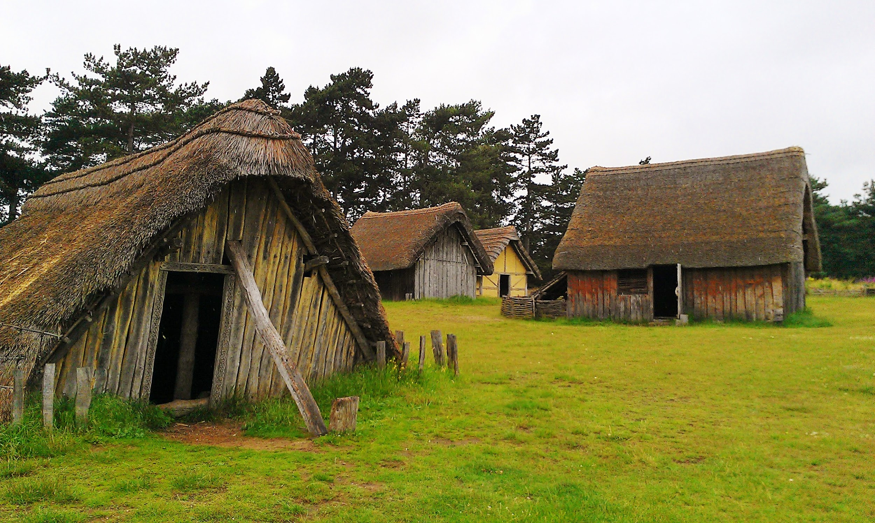  What was life like in Anglo-Saxon Britain?  What can we learn about the Vikings from what they left behind?  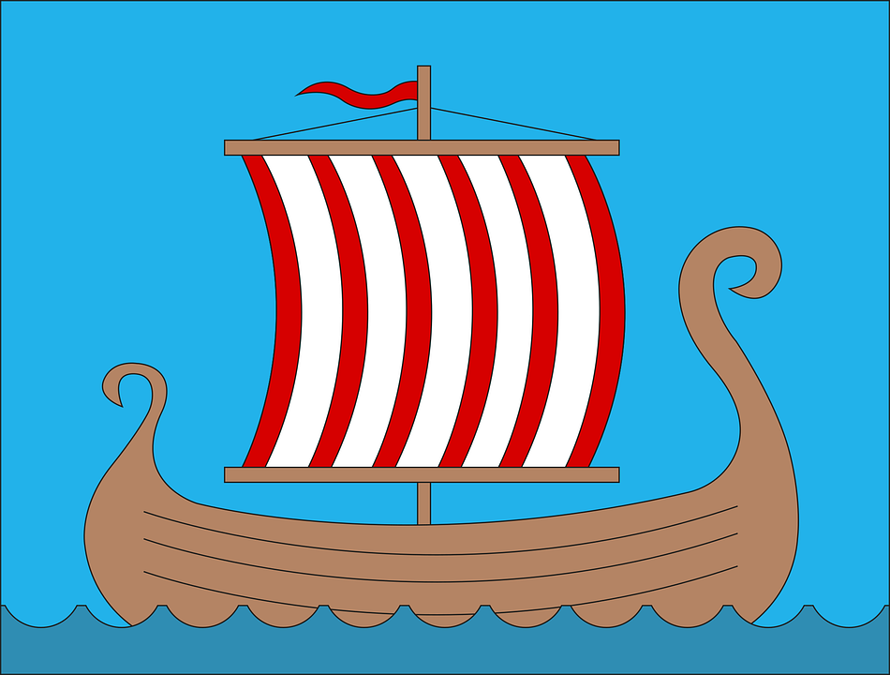  Using primary sources to understand the past. |  | Water, Ships and Seafarers  Sketching Viking Longboats  Using digital art to create a viking helmet  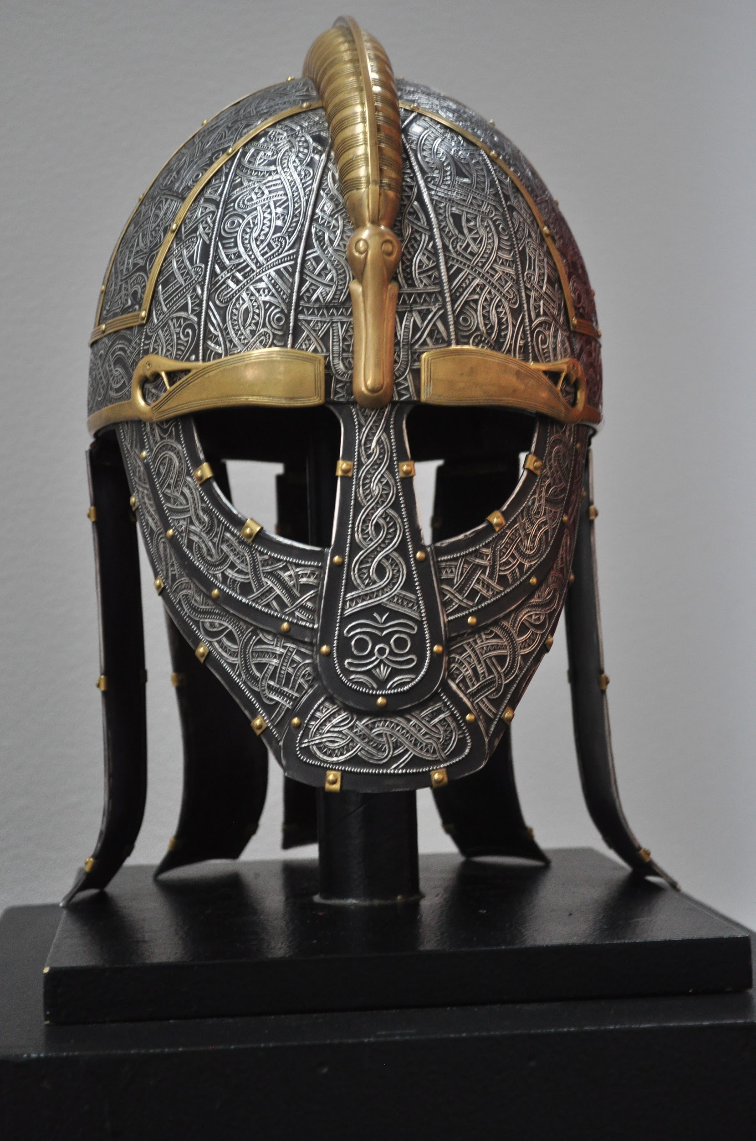  Creating a weaving loom  Using string printing | Royal Opera House - Create and Design  Using Royal Opera House resources, we will explore the role of set designers within ballet productions.  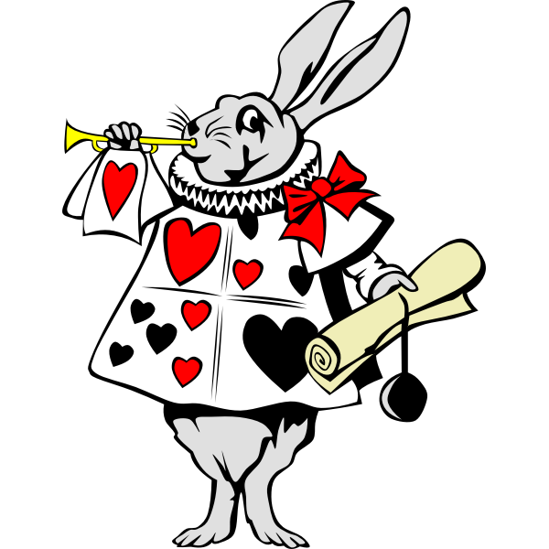  We will make their own model box designs to help tell the story of Alice’s Adventures in Wonderland.  This project allows children to work towards an Arts Award qualification. | Music will be a focus after half term  Our DT project will involve responding to music and using it to influence design decisions. | Netball  How do we pass and score in netball?  What are the roles of attackers and defenders?  What are the rules of netball? | Brain buddies  (Cambridgeshire Education Mental Health Support Team)  How can I identify and understand my emotions?  How do my thoughts and feelings influence how I act?  How can I help myself to stay calm and in control? | Photo Editing  In what different ways can photos be digitally edited?  Why might photos be digitally edited? | Matching Pairs  Names of key locations in towns and cities.  Giving opinions on activities.  Issue basic commands  Revising counting with questions and answers. | How do people pray?  What is prayer, and how is it done?  How do different religions pray?  