Year 2 Spring Term C - Our Learning

English | Maths
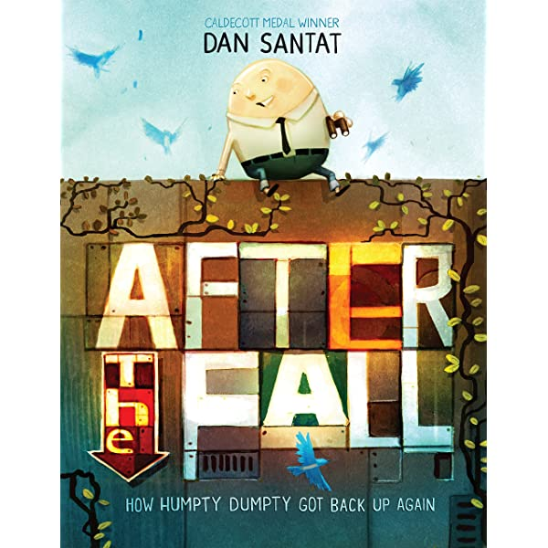  - Class book - After The Fall - we will be writing an adventure story from the viewpoint of a bird, happily soaring through the sky until something goes wrong!  - In preparation for Easter, we will be making chocolate Easter nests and writing a set of instructions to explain how they are made.  - We will be continuing our weekly handwriting sessions and phonics lessons. | 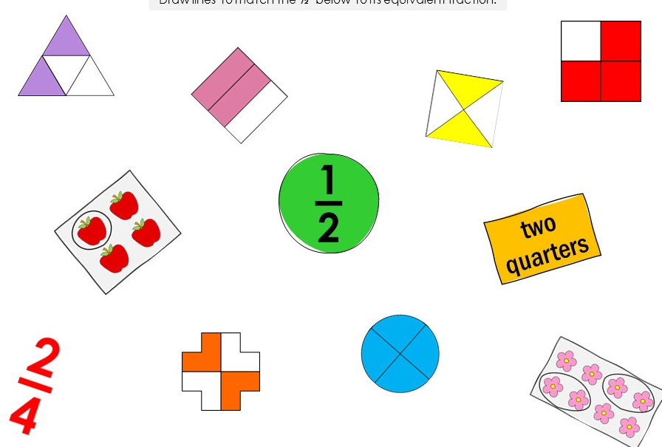  - Fractions - halves, quarters and thirds.  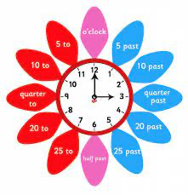  - Time - revision of half past, quarter past/quarter to and telling time to the nearest 5 minutes.  - Volume - measuring in litres and millilitres.
How you can help at home: | How you can help at home:
- Read with your child every day. Your child can read their school reading book to you using their phonic skills to work out new words. Encourage them to read familiar words quickly and fluently, and chat about the story together to check understanding.  - Read aloud to your child using the library book sent home from school or any other books your child enjoys. There are lots of free ebooks online and membership of March library is free as well. | Practise maths skills through everyday tasks such as:  - Counting objects, including by grouping into 2s, 5s and 10s  - Money - recognising the value of each type of coin and counting up the value of a small pile of coins  - Using digital and analogue clocks to tell the time - o’clocks, half past, quarter to and quarter past  - Cooking or baking together - using scales to weight the ingredients  - Naming 2D and 3D shapes you can see in the world around you. Which ones are symmetrical?

Science | History | Geography | Art and Design | Design Technology | Music | P.E. | P.S.H.E. | Computing | R.E.
Testing materials:  Can you find the best insulation for a yoghurt pot? | Comparing: Can you draw an object from the past and compare it with that of the modern day?  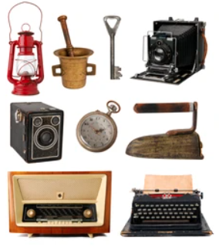 | Human/Physical features:  Can you compare March to the Isle of Coll?  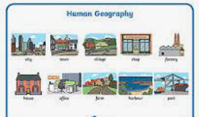  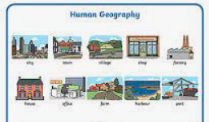 | Creating textures:  Can you use different mediums to show patterns in materials?  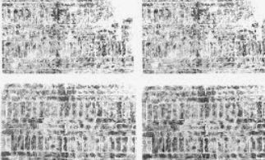 | Covered for the term. | To use sounds expressively to illustrate a story. | Reaction and response:  Developing ball chasing combinations.  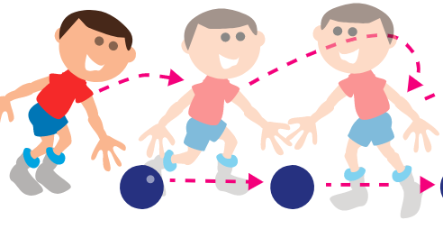 | Family and friends:  What is a good friend? How does it feel to have/be a good friend? | Making Music:  Can you digitally make a piece of music?  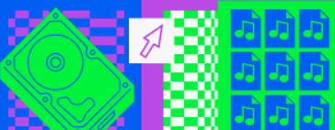 | Sikhism  How does the Khalsa influence the lives of Sikh families?

