Year 4 Spring Term B - February and March 2024 - Our Learning

English | Maths
- We will continue to read How to Train Your Dragon this term.  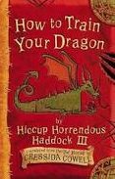  - Year 4 will be moving on to writing narratives in the  third person. These will be based upon Norse  Mythology, linked to our Saxon and Viking work in  History and Geography  - The children will learn a range of description and  dialogue techniques to successfully suspend a  reader's disbelief  - Children will be working in guided reading groups across the cohort, aiming to improve in an array of important reading skills | - We will start the half-term with fractions, which will involve counting in hundredths, finding equivalent fractions and adding and subtracting fractions.  - We will then begin our unit on time, focusing on converting between different units of time.  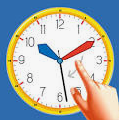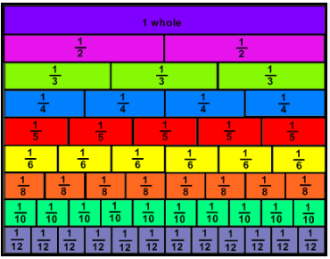
How you can help at home: | How you can help at home:
- Encourage your child to read daily (15 minutes or 15 pages a night)  - Learn weekly spellings (these are set as homework in the Y4 google classroom)  - Read with your child, even if they are a fluent and confident reader, asking comprehension questions; there are example questions to guide you in the Y4 google classroom | - Complete TT rockstars homework set weekly.  - Practise rapid recall of times tables and linked division facts - this is even more key as the MTC times table check approaches.  - Use opportunities to tell the time in daily life

Science | History | Geography | Art and Design | Design Technology | Music | P.E | PSHE | Computing | Spanish | RE
Human nutrition  We will learn about digestion and what happens to food as we digest it. We will learn why we have to eat certain types of food to keep us healthy.  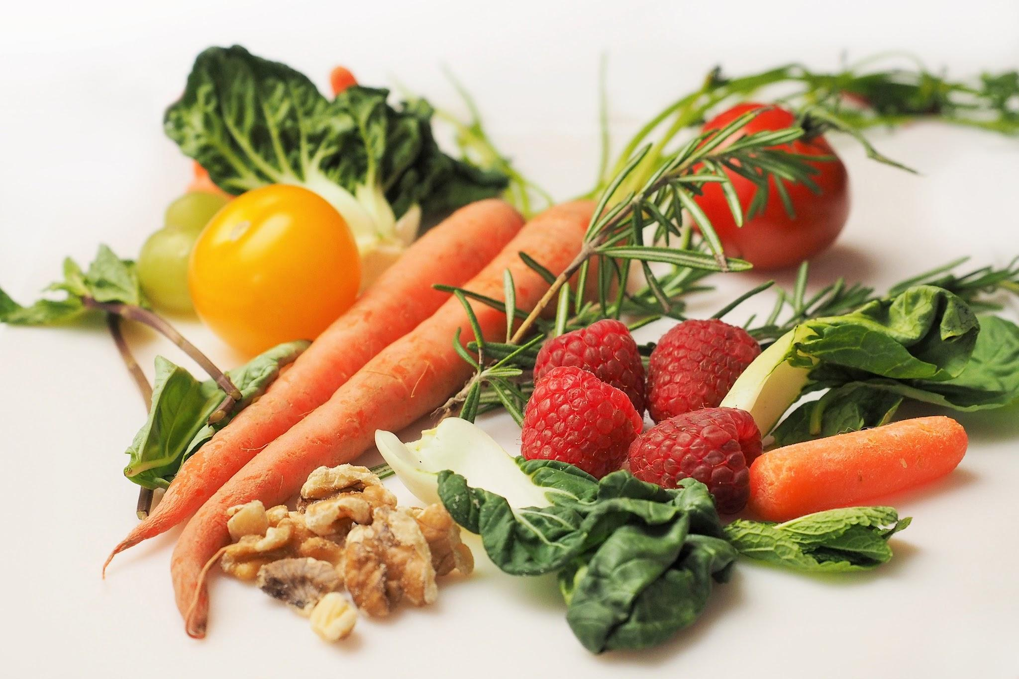 | Water, Ships and Seafarers  Who were the Anglo-Saxons and Vikings and where did they come from?  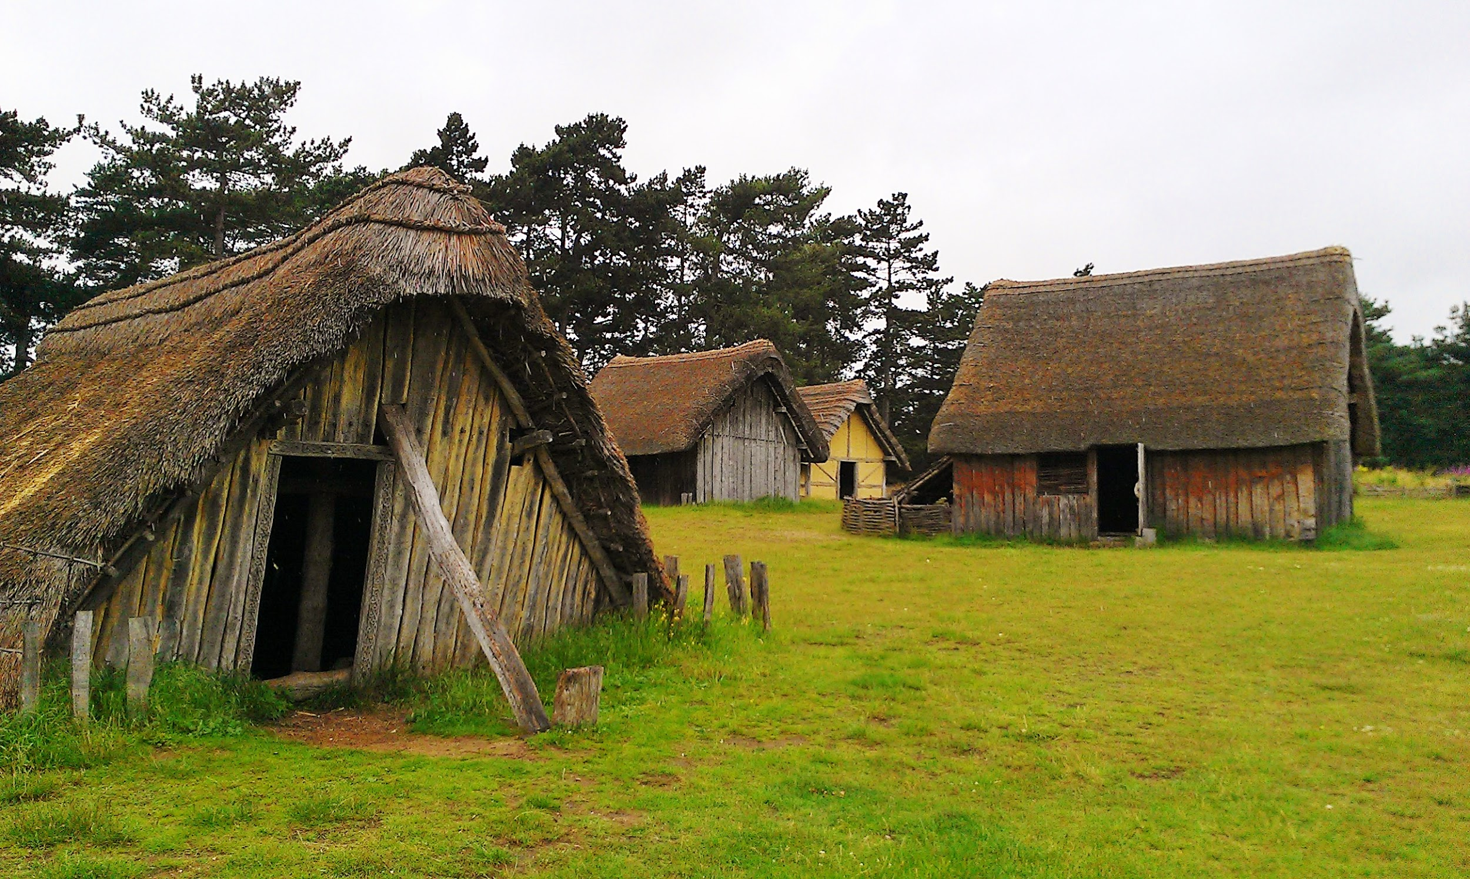  What was life like in Anglo-Saxon Britain?  What can we learn about the Vikings from what they left behind?  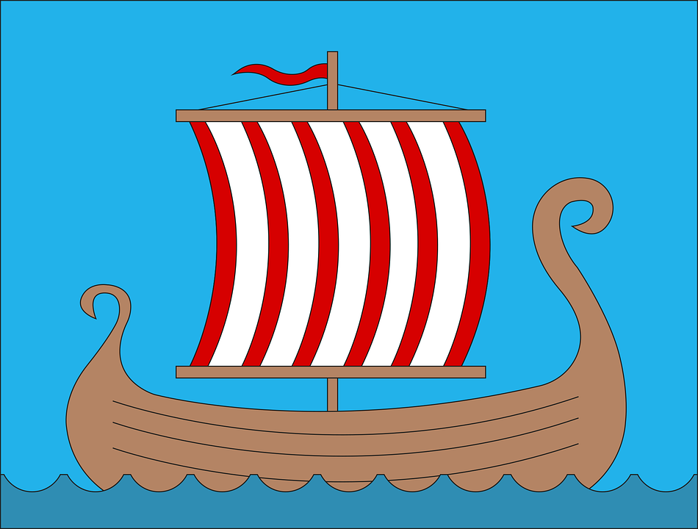  Using primary sources to understand the past. |  | Completed last half-term | Weaving  The children will be taught how to set up a card weaving loom. Using natural coloured wool, they will then learn to weave.  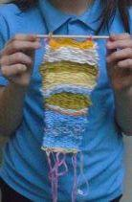 | Completed last half-term | Hockey  How do we position ourselves when holding a hockey stick?  How do we effectively pass, shoot and tackle?  What are the rules of hockey?  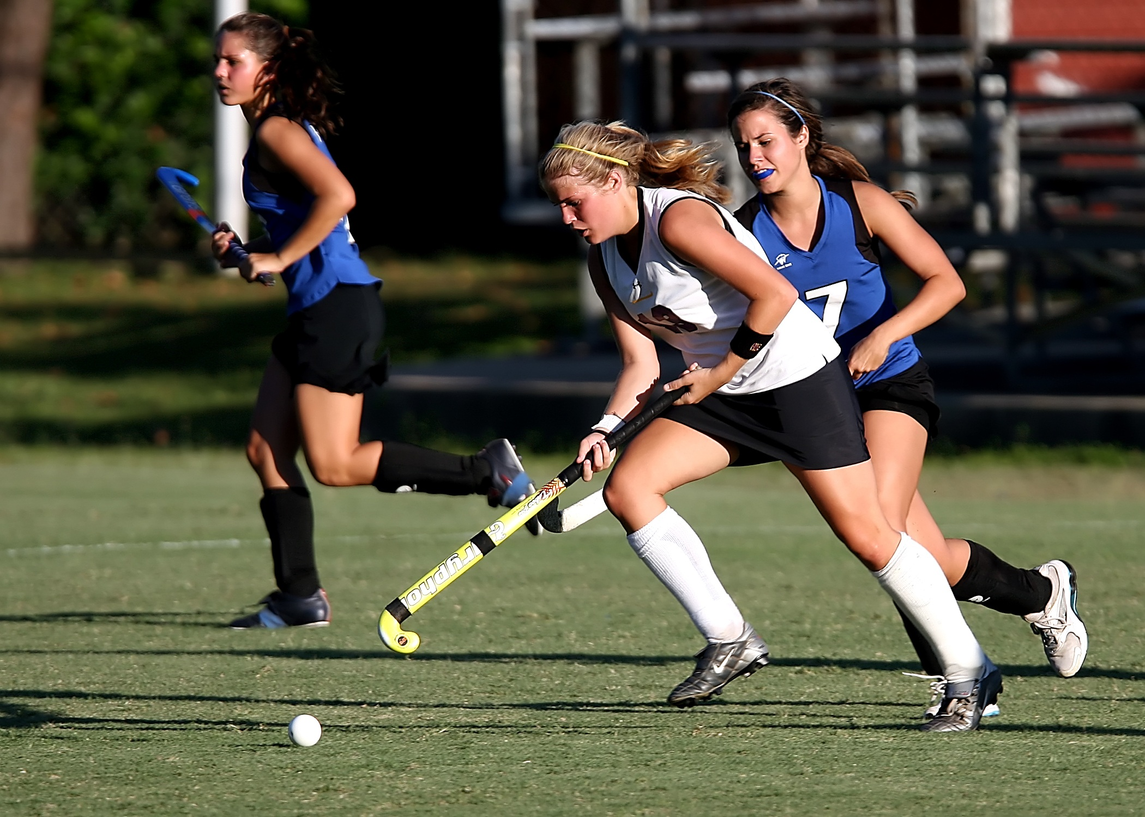 | Sex and relationships  Looking at the idea of growing up and the human lifecycle.  Financial capability  Focusing on the idea of earning money and then saving it up. | Photo Editing  In what different ways can photos be digitally edited?  Why might photos be digitally edited? | Animals  We will learn the names for animals and how to describe them in a sentence. | Is Easter a festival of new life or sacrifice?  What were the events that happened over Lent and Holy Week?  Why did Jesus have to die?  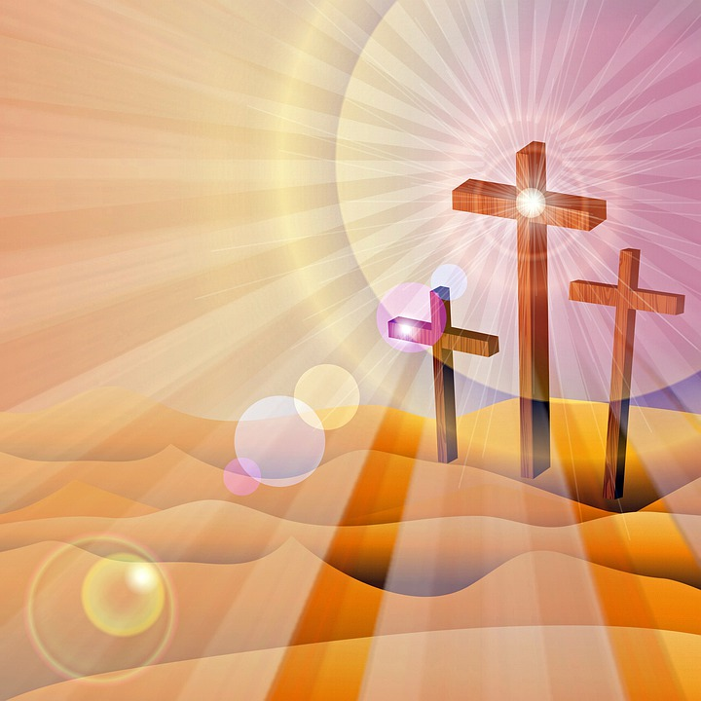  Why are the Resurrection and Pentecost vital to christians?

