Year 5 Spring Term B - February and March 2023 - Our Learning

English | Maths
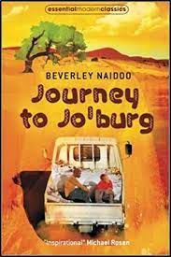  - Our class book this term is ‘Journey to Jo’burg’ by Beverley Naidoo. It tells the story of two children who grew up during the apartheid in South Africa.  - Out text focus wil be newspaper reports. We will learn how to write a newspaper report, and then link this to the life of Nelson Mandela. | 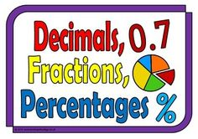  - Decimals - writing, adding and subtracting decimals, place value  - Percentages - what is a percentage, writing and finding percentages  - Geometry - measuring and calculating angles, 2D and 3D shapes
How you can help at home: | How you can help at home:
- Read with your child, even if they are a fluent and confident reader, asking comprehension questions; there are example questions to guide you in the Y5 google classroom  - Encourage your child to read independently for sustained periods - 20 minutes or 20 pages a night.  - Learn weekly spellings | - Encourage your child to complete weekly homework - TT rock stars tasks set weekly  - Practise rapid recall of times tables and linked division facts  - Use opportunities to tell the time in daily life  - You will find a summary of the written calculation methods we teach in school in the Y5 google classroom.

Science | History | Geography | Art and Design | Design Technology | Music | P.E | PSHE | Computing | Spanish | RE
How does light travel?  We will explore the movement light takes to enter our eyes. We will experiment with reflecting light and how shadows are created. | Completed last half-term | How does March compare with Llangollen?  We will carry out studies of both areas and then compare the human and physical geography of the two. | Completed last half-term | Textiles - We will design and make a a quiver (belt) which a soldier could wear to hold his bow and arrow safe whilst he walks around the castle. | Completed last half-term | Hockey - We will continue to learn how to hold a hockey stick correctly and use it to pass and shoot. Apply learning to match conditions.  .  Core PE - We will focus on the social skills we need to be part of a successful sports team. | My Emotions:  Mental health strategies  Managing strong emotions  Responding to others | Video editing - We will learn how to create short videos including capturing and editing video. | Spanish - We will learn how to tell the time in spanish, including phrases for o’clock, and securing numbers to 12. | What is Easter?  Revisiting the Easter story and being able to tell it in our own words.  