Year 1 Spring Term C - Our Learning
English | Maths
- Daily phonics lessons for all children, which includes reading (Sounds, words, sentences and books), writing and spelling.  - Class books: Dogger and How to be a Viking.  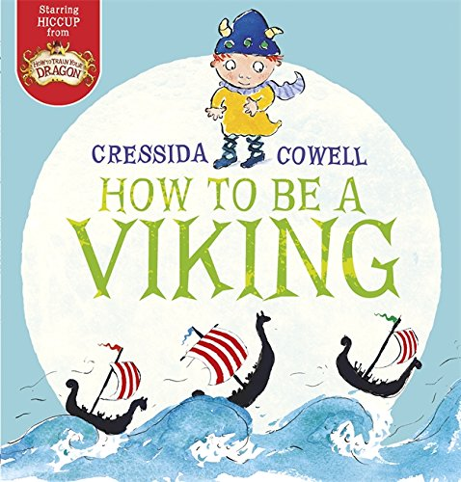  - Weekly activities across the curriculum will be inspired by our class books.  - Create my own sentence - build it in my  head, rehearse it, remember it and  write it using my phonics to help me spell.  - Use capital letters and full stops. | - Numbers to 40 - counting and writing these numbers as well as comparing them.  - Addition and subtraction word problems - using all the methods we have taught so far this year.  
How you can help at home: | How you can help at home:
- Read with your child every day. Your child can read their school reading book to you using their phonic skills to work out new words. Encourage them to read familiar words quickly and fluently, and chat about the story together to check understanding.  - Read aloud to your child using the library book sent home from school or any other books your child enjoys. There are lots of free ebooks online and membership of March library is free as well. | Practise maths skills through everyday tasks such as:  - Counting objects, including by grouping into 2s, 5s and 10s  - Money - recognising the value of each type of coin and counting up the value of a small pile of coins  - Using digital and analogue clocks to tell the time - o’clocks, half past, quarter to and quarter past  - Cooking or baking together - using scales to weight the ingredients  - Naming 2D and 3D shapes you can see in the world around you. Which ones are symmetrical?

Science | History | Geography | Art and Design | Design Technology | Music | P.E. | P.S.H.E. | Computing | R.E.
Matching objects to suitable materials  Investigating protective packaging  Exploring powders   | Visit to the toy museum!  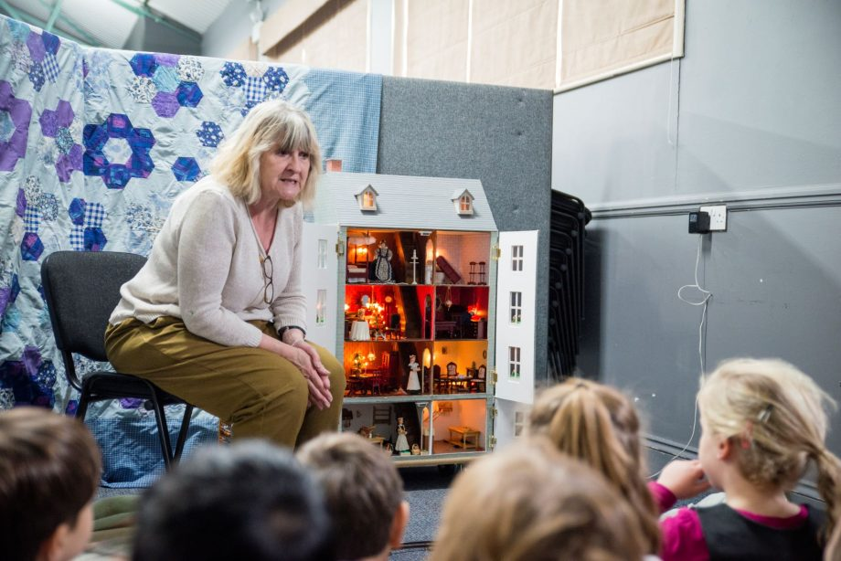 | Looking at maps and understanding birds eye view  Differences between maps and plans  Drawing a map to go with the story ‘Where’s my teddy?’ by Jez Alborough | Printing with toys using car wheels, lego, building bricks  Using the ipad to compose picture of favourite toy | Creating an Easter card with moving parts.   | Experiment with, create, select and combine sounds.  Work with tuned and untuned percussion to compose sounds depicting a falling feather.   | Exploring agility - reaction and response  Using equipment appropriately and moving and landing safely  Using apparatus to rotate on bottom and patter turn | Caring for the environment, animals and plants  Understanding how they can help to look after the school environment | Using Scratch Jr to design an animation with moving sprites  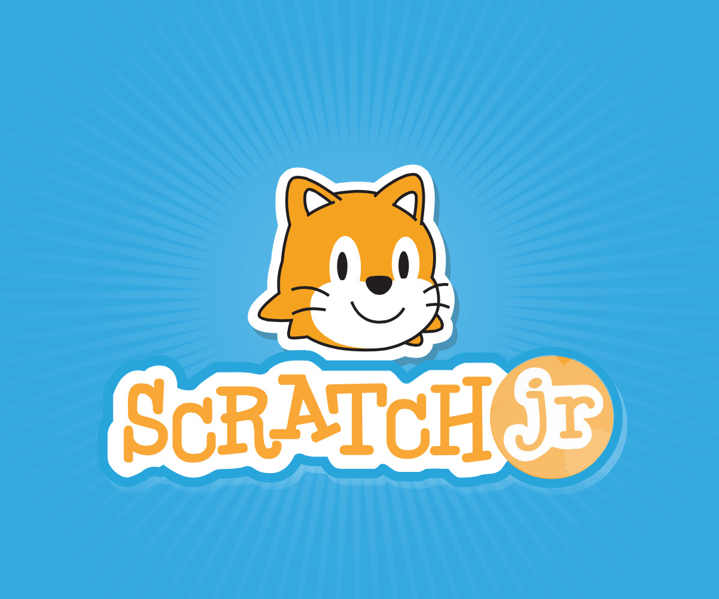 | Understanding how Christians and Muslims celebrate new life  Considering how a new baby is welcomed into the world

