Year 4 Spring Term A - January and February 2024 - Our Learning

English | Maths
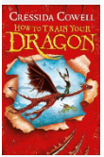  - In English, our class reader for this term is  How to Train Your Dragon by Cressida Cowell.  - We will be using this book to help us learn how  to write effective and detailed recounts.  - After recounts, we will focus on narrative writing.  We will write our own Viking stories after reading  Viking myths and legends. | 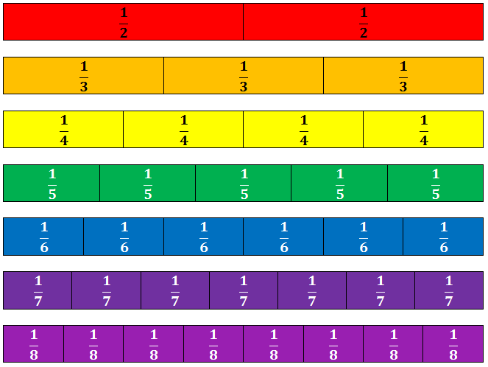  - In Maths this half-term, we will look at reading, interpreting and drawing a range of graphs before beginning to think about fractions.  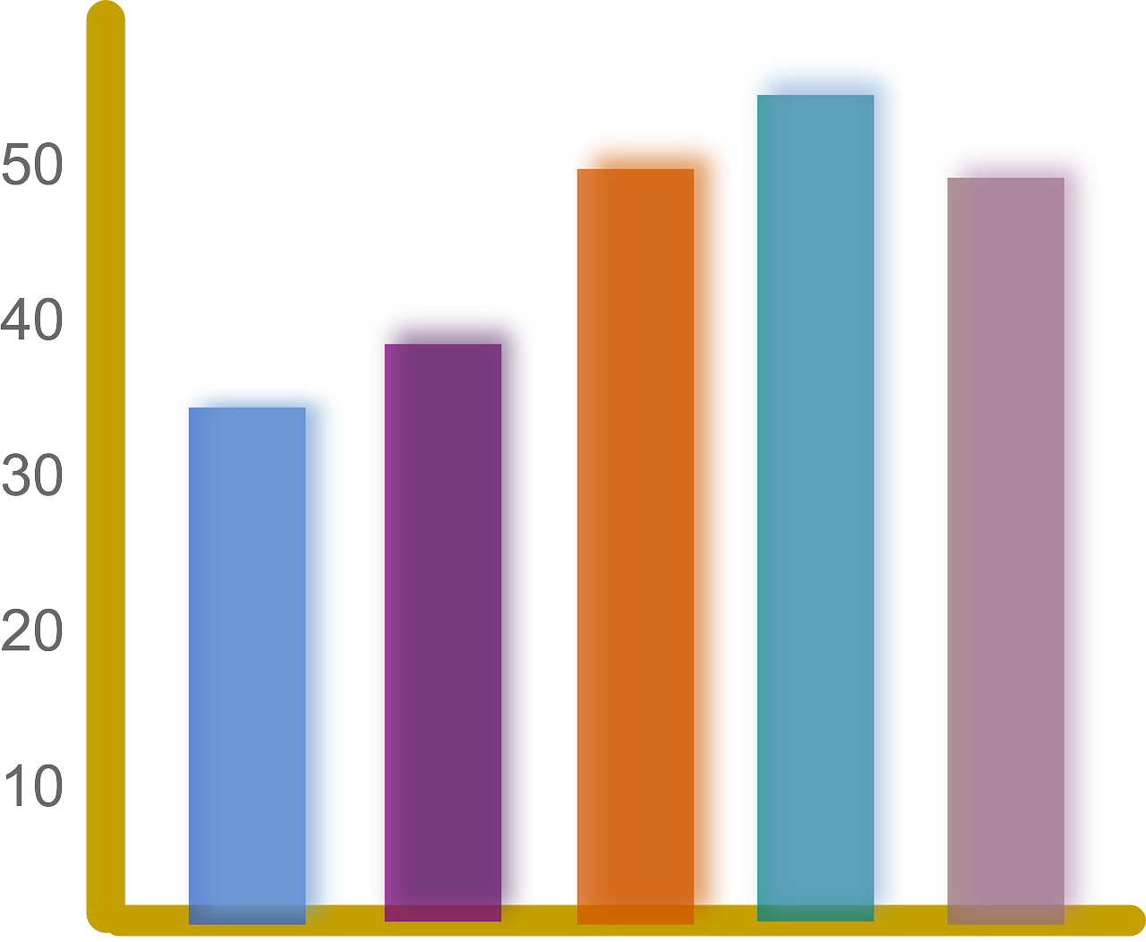
How you can help at home: | How you can help at home:
- Encourage your child to read daily (15 minutes or 15 pages a night)  - Learn weekly spellings (these are set as homework in the Y4 google classroom)  - Read with your child, even if they are a fluent and confident reader, asking comprehension questions; there are example questions to guide you in the Y4 google classroom | - Complete TT rockstars homework set weekly.  - Practise rapid recall of times tables and linked division facts - this is even more key as the MTC times table check approaches.  - Use opportunities to tell the time in daily life

Science | History | Geography | Art and Design | Design Technology | Music | P.E | PSHE | Computing | Spanish | RE
Sound  How is sound made?  How do we hear? | Water, Ships and Seafarers  Who were the Anglo-Saxons and Vikings and where did they come from?  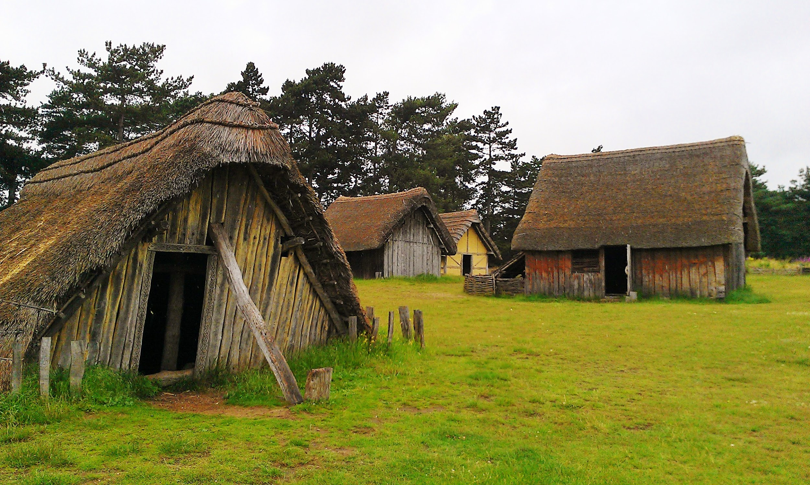  What was life like in Anglo-Saxon Britain?  What can we learn about the Vikings from what they left behind?  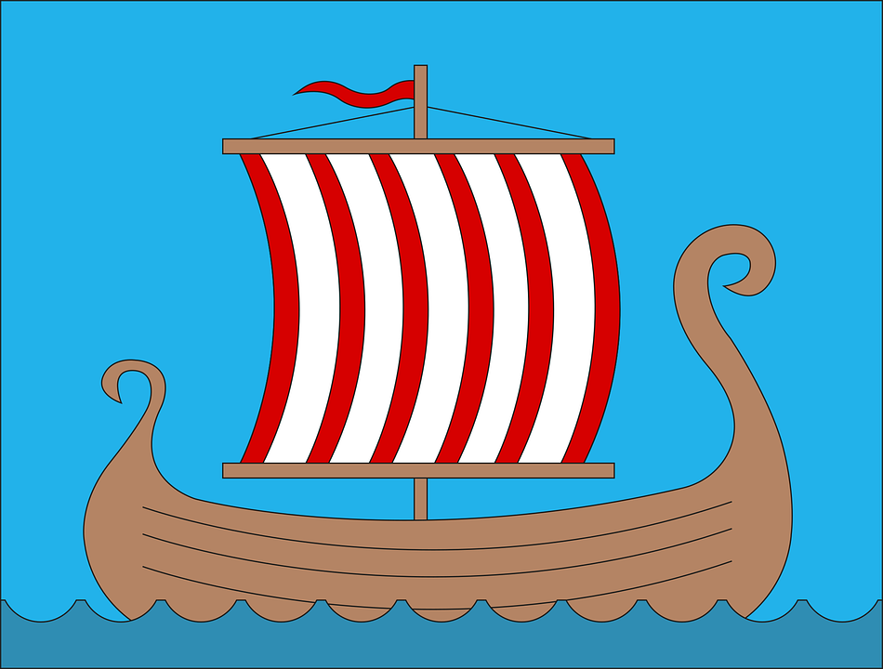  Using primary sources to understand the past. |  | Water, Ships and Seafarers  Sketching Viking Longboats  Using digital art to create a viking helmet  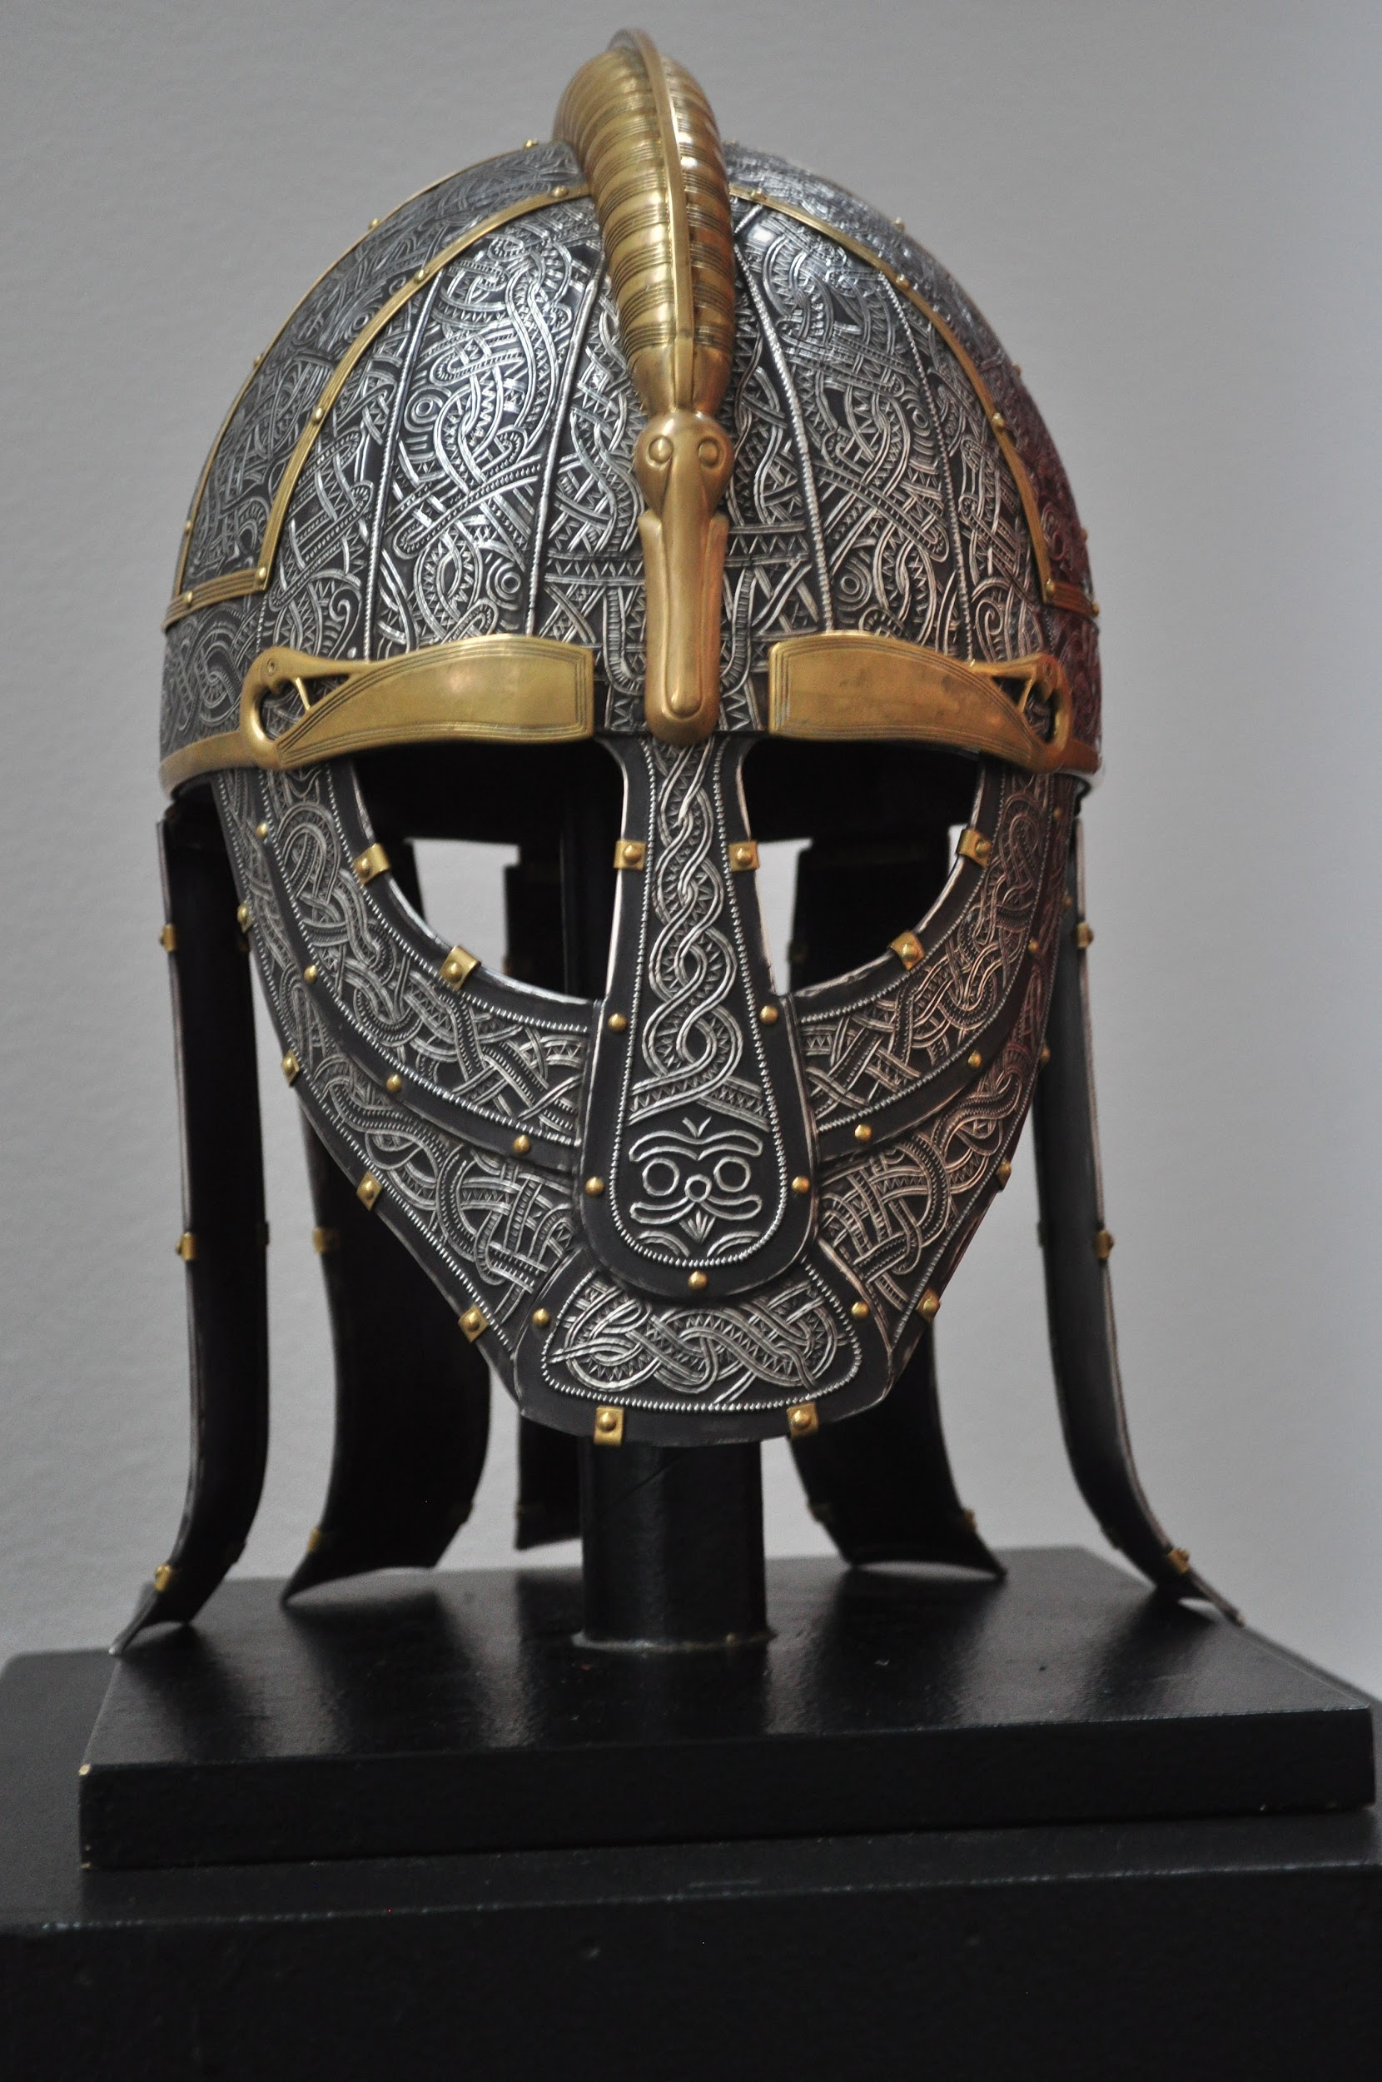  Creating a weaving loom  Using string printing | We will focus on DT after half-term. | Composition  As well as responding to music through our DT project, we will be using what we have learned in History and Geography to create call and response compositions. | Netball  How do we pass and score in netball?  What are the roles of attackers and defenders?  What are the rules of netball? | Working together  We will learn about the skills needed to work well as part of a team, understanding that there may be challenges!  Risk.  We will learn what risk is and how we should behave in a risky situation. | We will focus on Computing after half-term. | Numbers to 100  Pets | How do people pray?  What is prayer, and how is it done?  How do different religions pray?  