Year 3 Spring Term 1 - January and February

English | Maths
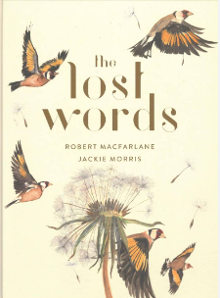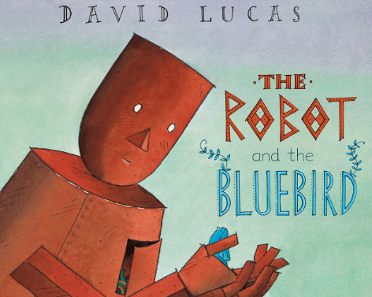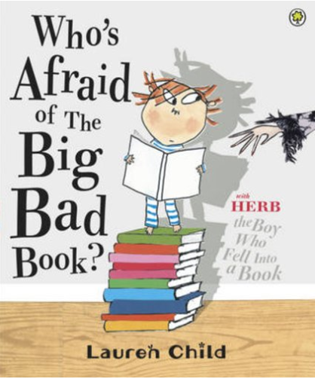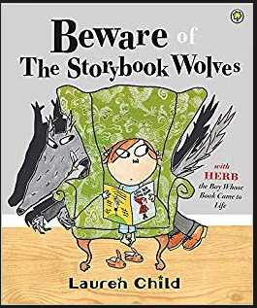  Class books: The Lost Words, The Robot and the Bluebird, Who’s Afraid of the Big, Bad Book, Beware of the Storybook Wolves  - Recognising and writing different types of poetry including acrostic and haiku poems.  - Writing our own versions of well-known fairy tales, thinking about character, setting and plot.  - Continuing to build knowledge of grammar and spelling including prepositions and suffixes. | Division / Mass  - Multiplying 2 - digit numbers e.g., 36 x 3 =  - They will be using column multiplication to help them with this.  - Dividing using the bus stop method.  - Divide a 2-digit number by a 1-digit number with and without renaming.  - Read and write length and height in metres, centimetres and millimetres.  - Read and write vocabulary related to mass.  - Measure and compare using kilograms and grams, and know the relationship between them.  - Suggest units and equipment to estimate or measure mass.  - Read scales.  - Record measurements.
How you can help at home: | How you can help at home:
- Read with your child, even if they are a fluent and confident reader, asking comprehension questions; there are example questions to guide you in the Y3 google classroom  - Encourage your child to read independently for sustained periods  - Learn weekly spellings - you can use the booklet sent home to practise them every day. You can also find these in the google classroom.  - Complete spelling homework in the Y3 google classroom by Friday each week. | - Practise rapid recall of times tables and linked division facts with a focus on the 4s,8s and 3s up to 12x  - Encourage your child to use TT Rock Stars to practise times tables facts  - Use opportunities to tell the time in daily life  - You will find a summary of the written calculation methods we teach in school in the Y3 google classroom.

Science | History | Geography | Art and Design | Design Technology | Music | P.E | PSHE | Computing | Spanish | RE
Forces and magnets  How do things move on different surfaces?  Exploring magnetism.  Which objects are attracted to magnets and why?  How do objects attract or repel each other and some materials?  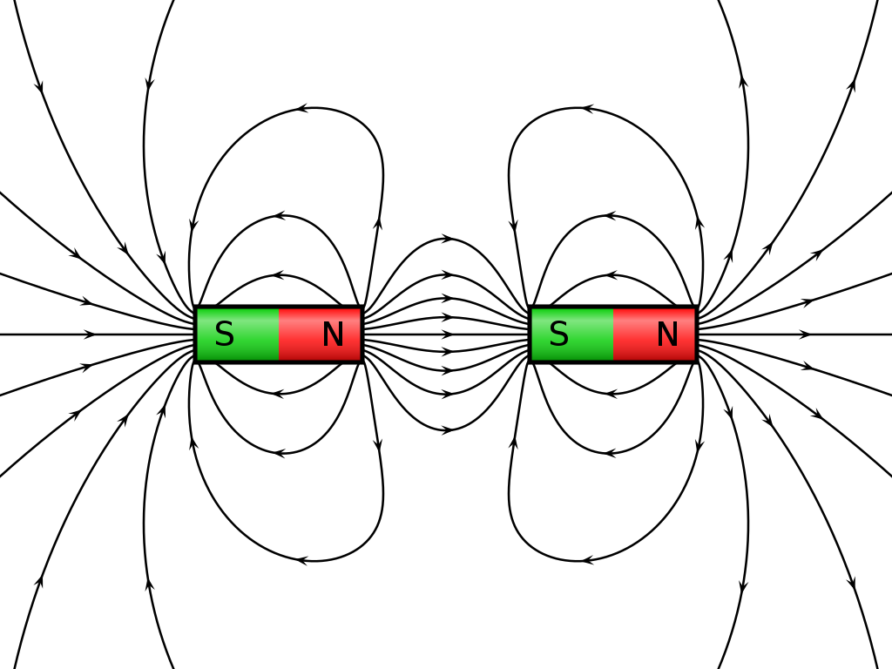 | The Celts and the Iceni.  Who were the Celts?  How did the Celts build their villages?  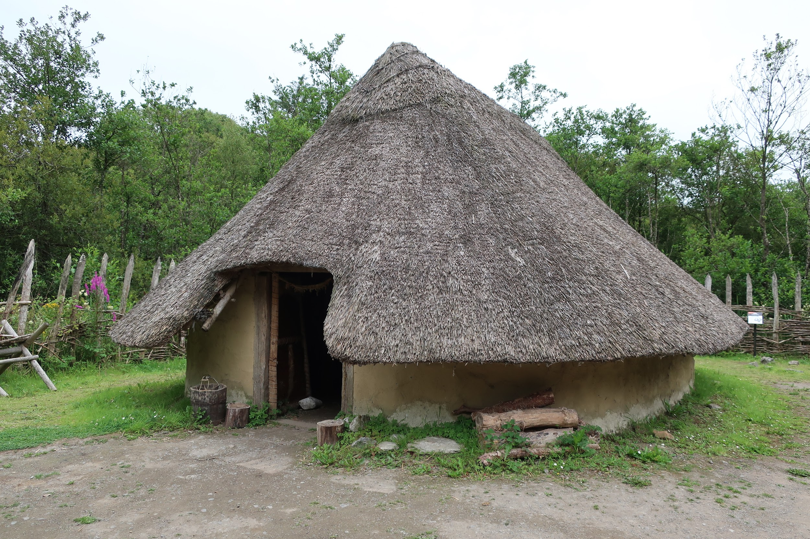  Who were the Iceni and what did they believe?  What was the celtic warrior like?  What happened to the Celts? | To be taught in Spring B. | Where we live  Sketching objects and different elevations.  Observing and discussing the style of landscape artists.  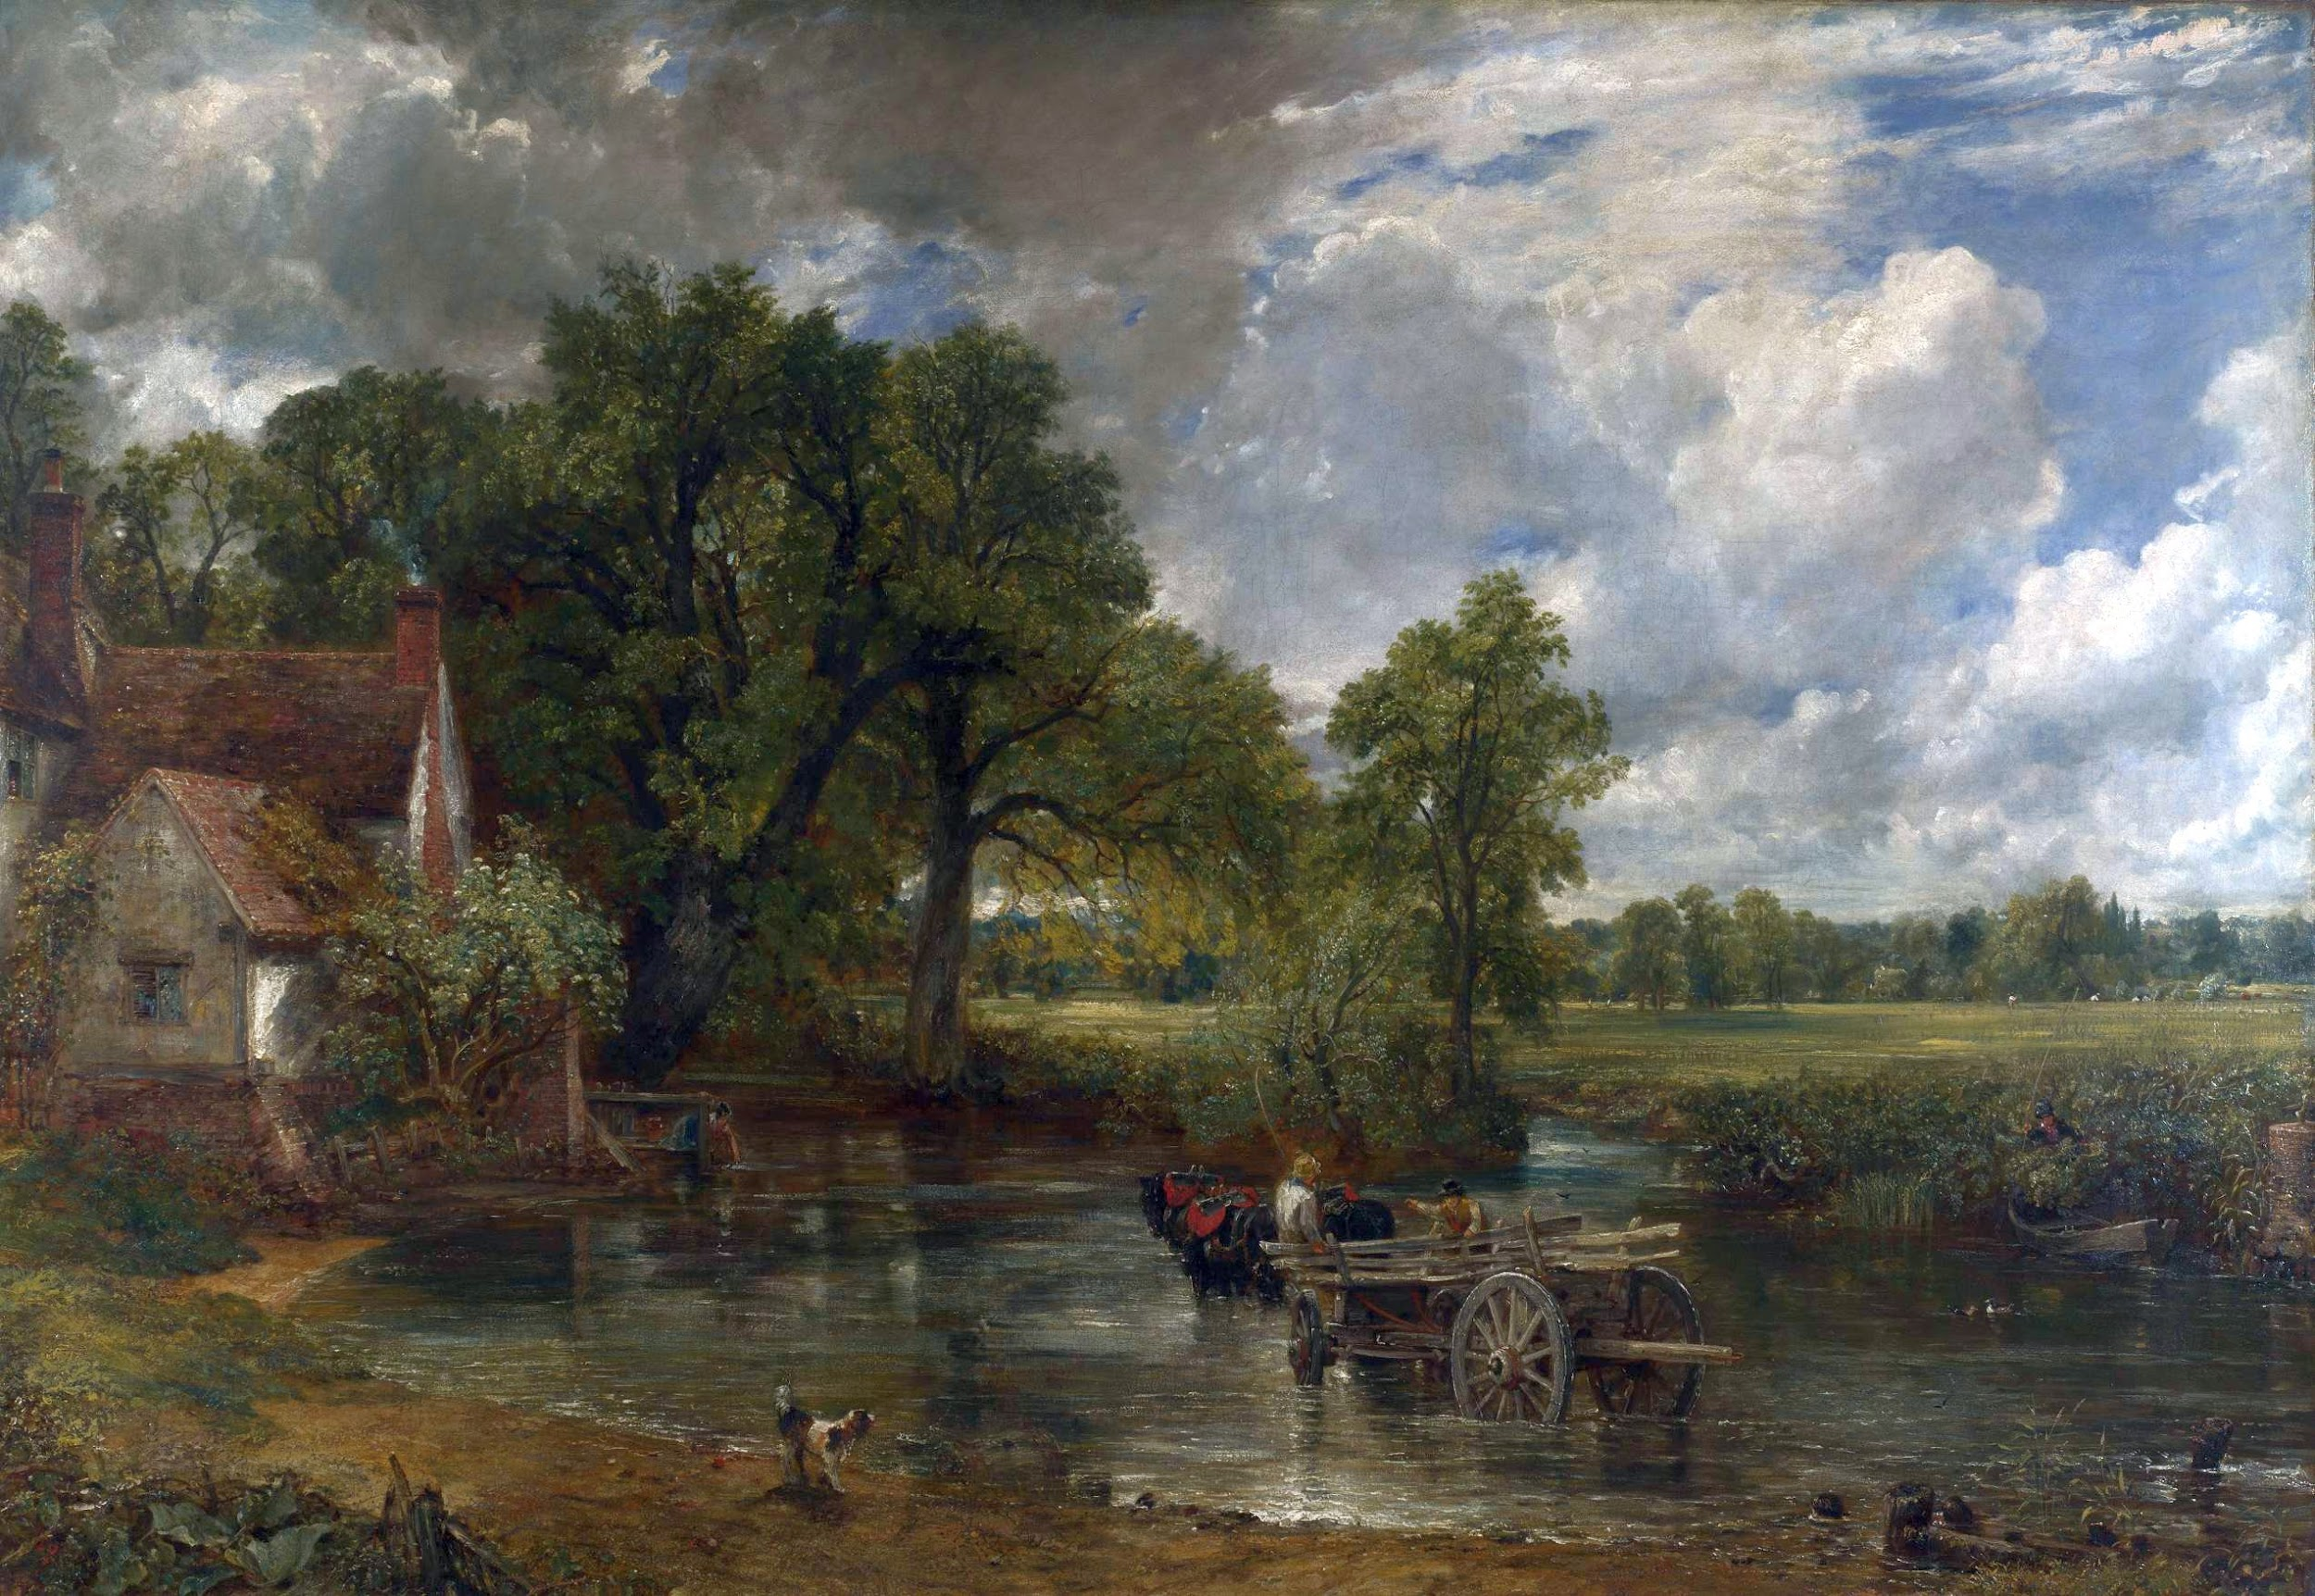  Using various media.  Evaluating and discussing the works of other artists. | To be taught in Spring B. | To be taught in Spring B. | Netball  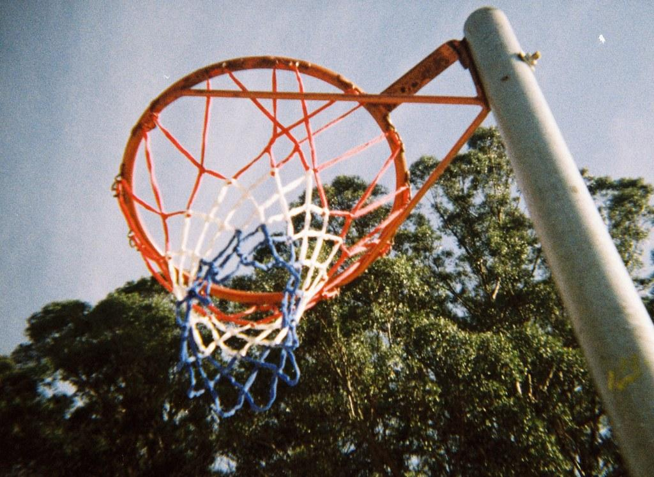  Real Dance  Exploring standing and moving shapes.  Exploring and developing shapes including circles in dance. | Managing safety and risk  What is my role in helping my school to be a safe place?  How can we build relationships in our class and how does this benefit me?  What does it feel like to be new or start something new?  Who are the different people in my network and who can I ask for help? | Programming sequences in music  Link sounds to events  Control a sprite with a chosen command  Create and run simple programs using code  Software: Scratch | Learning to ask ‘What is your name?’  Pronouncing key colours in spanish. | Is it Fair?  What is fair?  Can we change the world?  Should everyone be treated the same? What do Christians say?  How do some people work to make the world fairer for everyone?

