Year 6 Spring Term B - February and March 2024 - Our Learning

English | Maths
- We will be continuing to read ‘City of Ember’ as our class reader  - Writing narratives with dialogue, punctuating correctly  - Writing an extra chapter for our class reader  - Weekly comprehension lessons to build skills for the upcoming SATs  - Grammar and spelling quizzes  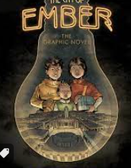 | - Pupils will be adding and subtracting negative numbers.  - Pupils will differentiate between translation and reflection on a coordinate grid before moving on to express movement using algebra.  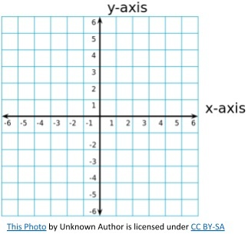  - Pupils will learn to present and interpret information in different ways.  - Pupils will continue to develop their arithmetic and reasoning skills to support Year 6 maths.
How you can help at home: | How you can help at home:
- Read with your child, even if they are a fluent and confident reader, asking comprehension questions; there are example questions to guide you in the Y6 google classroom  - Encourage your child to read independently for sustained periods  - Learn weekly spellings (these are set as homework in the Y6 google classroom) | - Encourage your child to complete weekly homework - SATS Companion tasks set weekly on Fridays  - Practise rapid recall of times tables and linked division facts. TT Rockstars homework is set each week  - Use opportunities to tell the time in daily life

Science | History | Geography | Art and Design | Design Technology | Music | P.E | PSHE | Computing | Spanish | RE
Life cycles  We will learn the differences in the life cycles of a mammal, an amphibian, an insect and a bird. 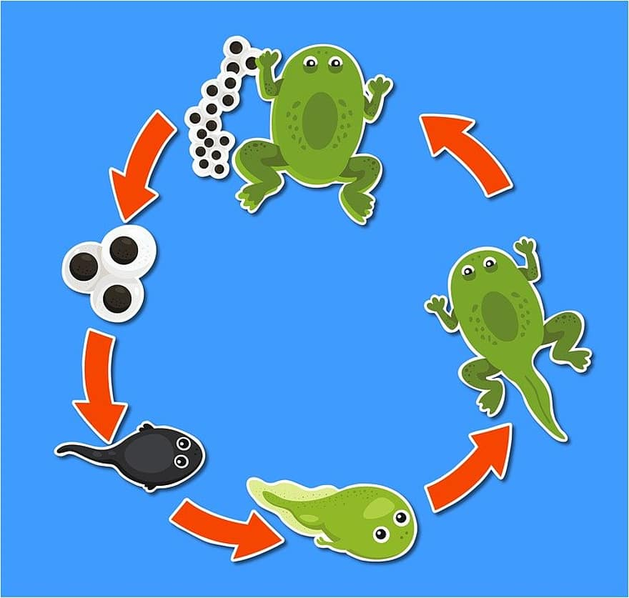 | The Tudors  This term the children will learn about the Tudor dynasty including Elizabeth I and about Tudor explorers.  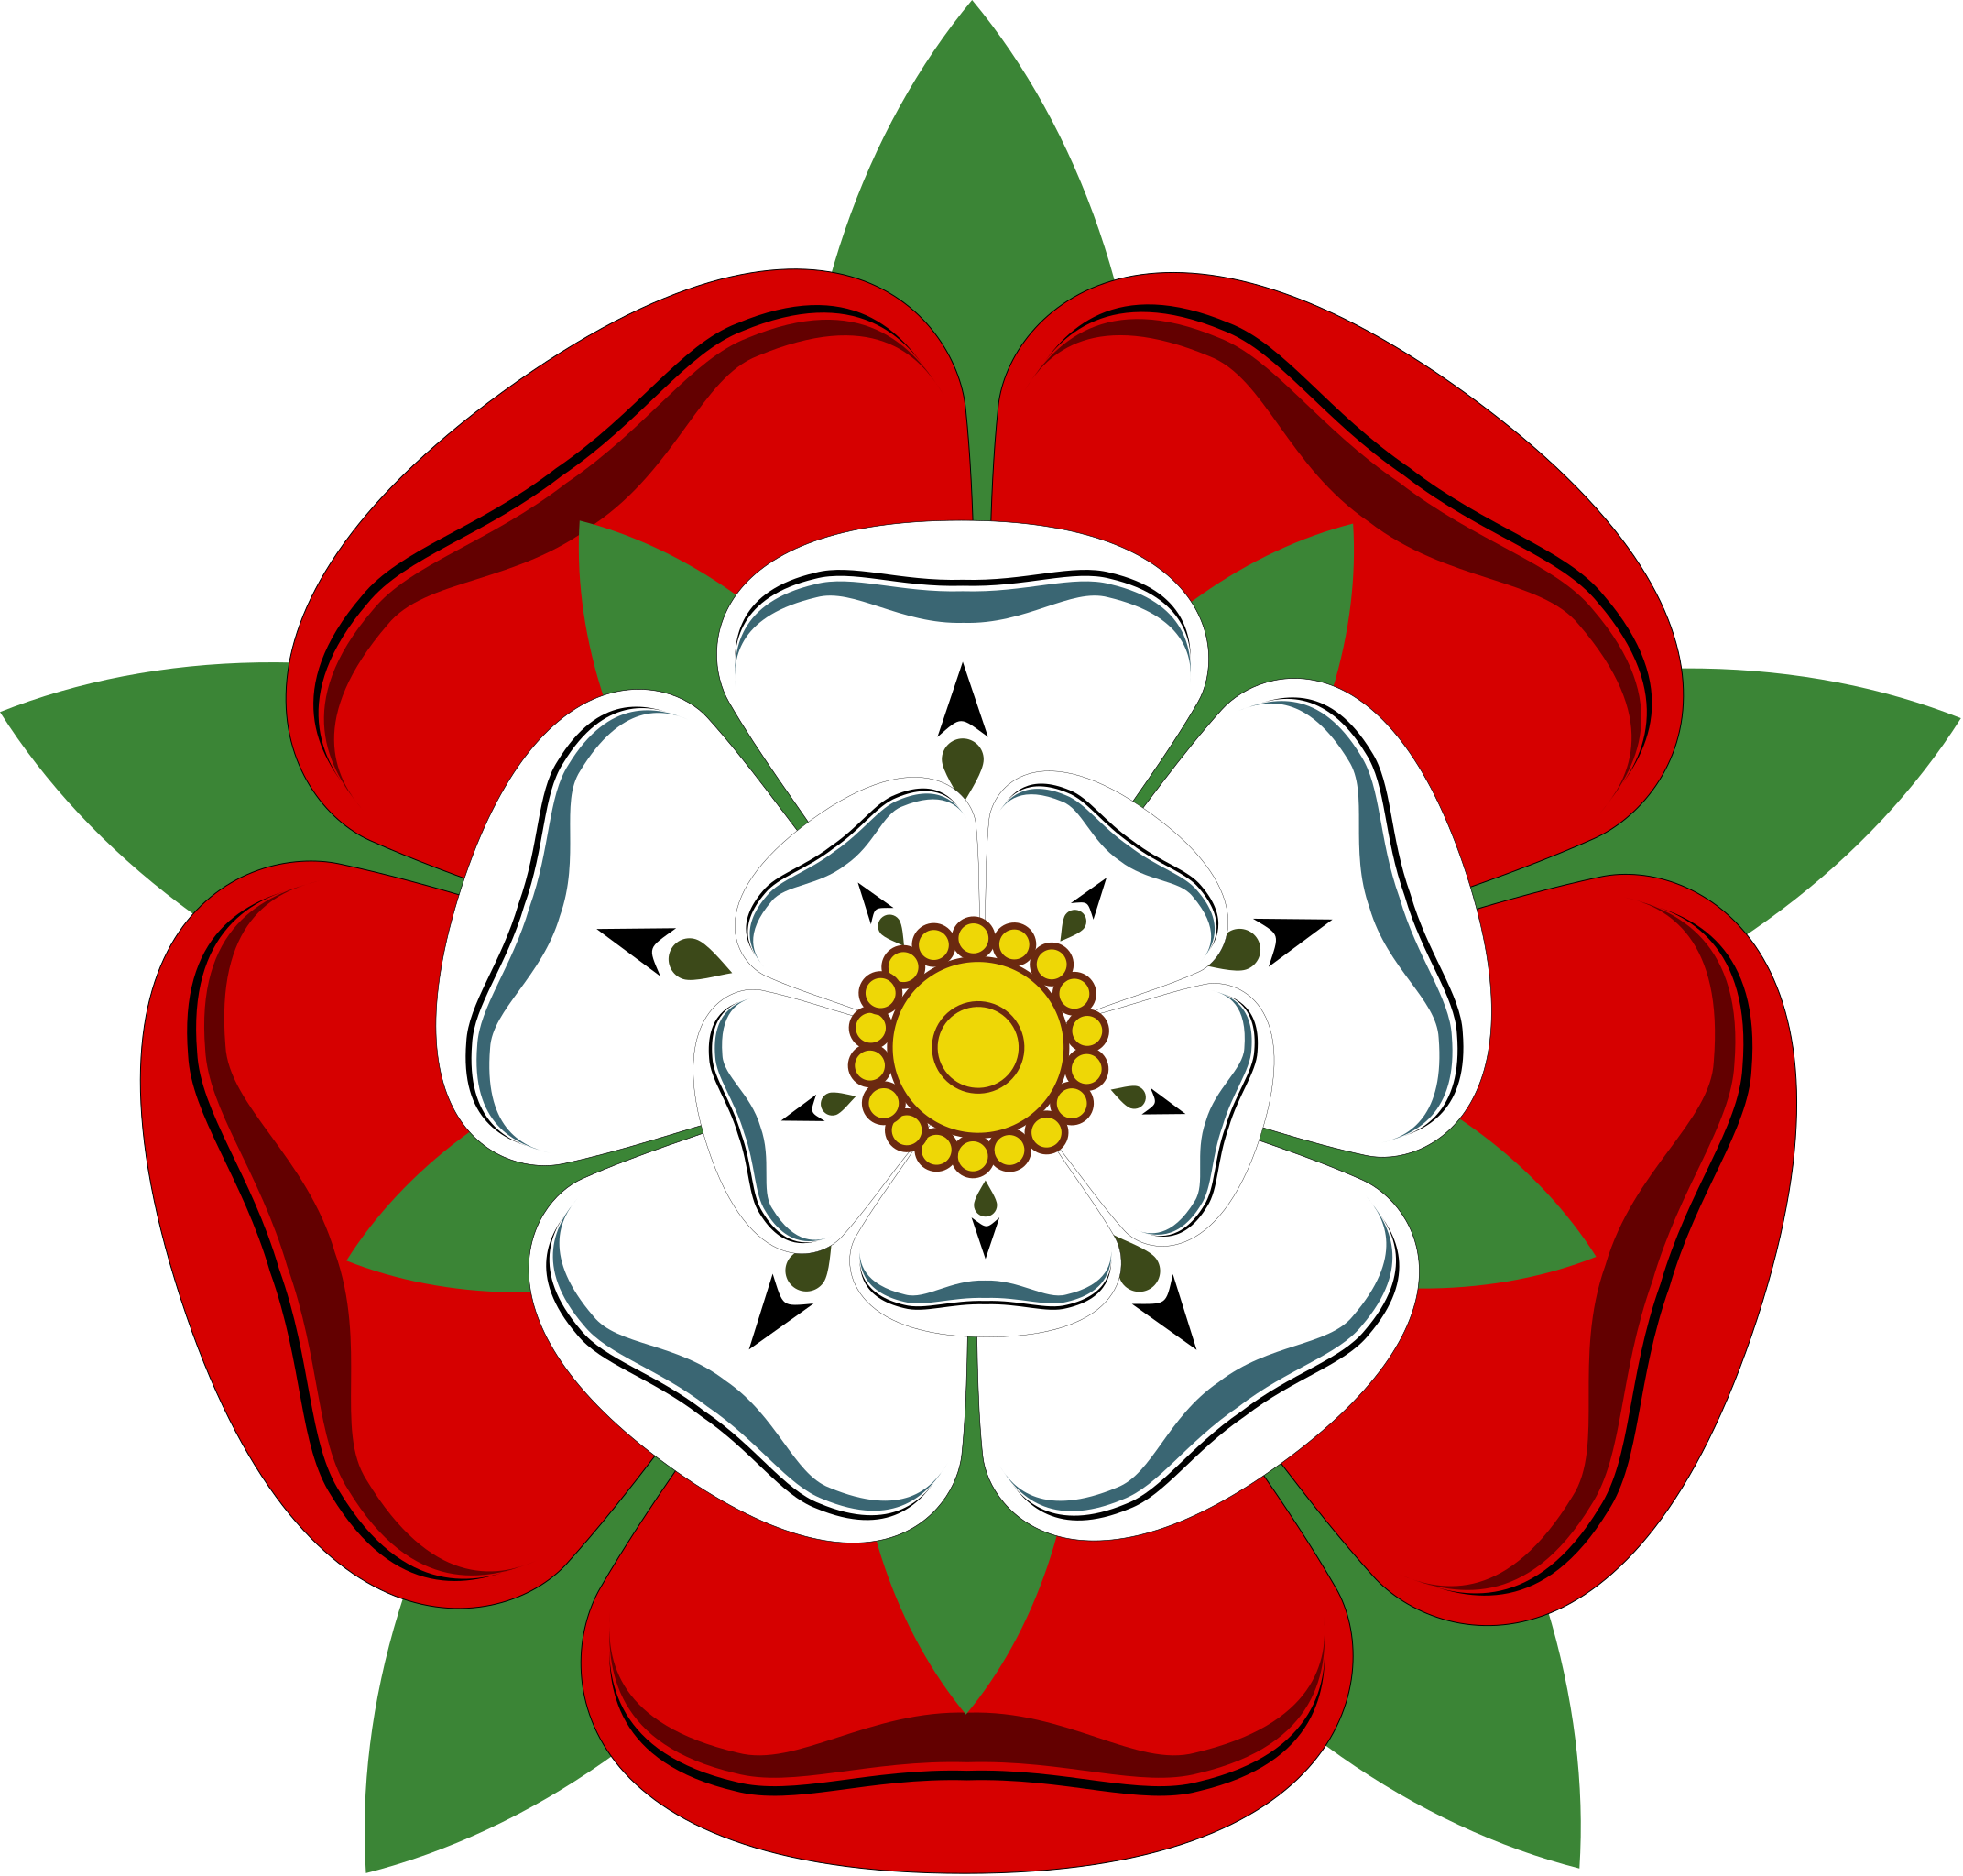 | This was taught last half term. | Life Cycles  Pottery skills to successfully create a decorated cylinder sculpture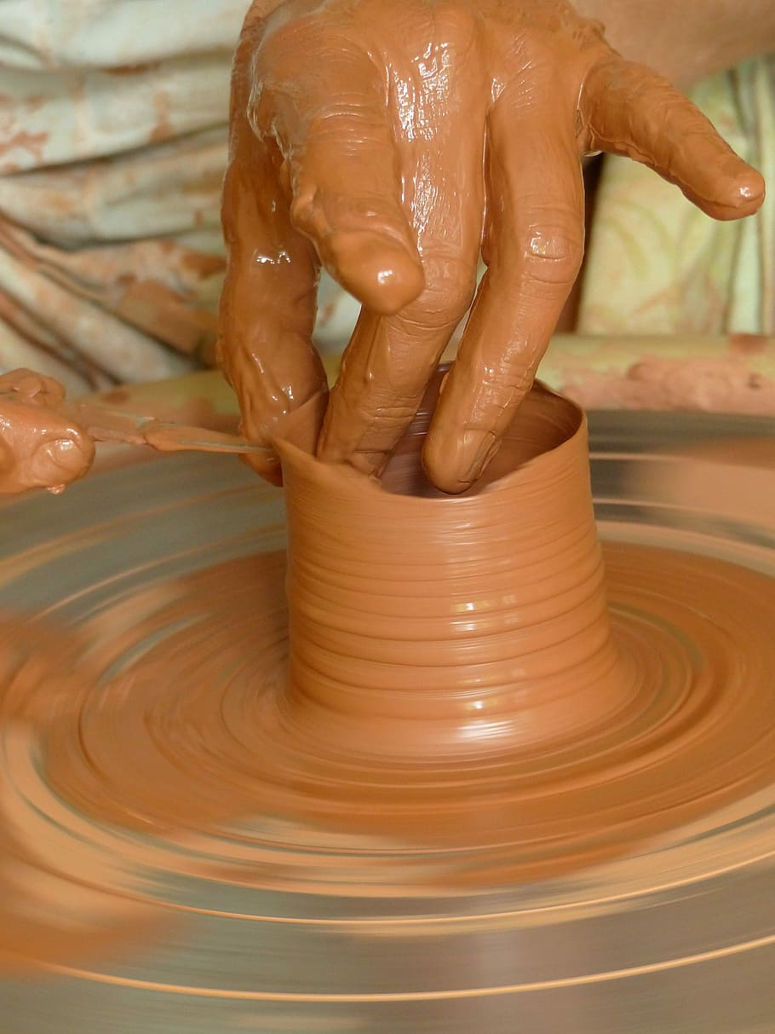 | Space Toy  The children will be continuing to make a space toy for a younger child from felt.  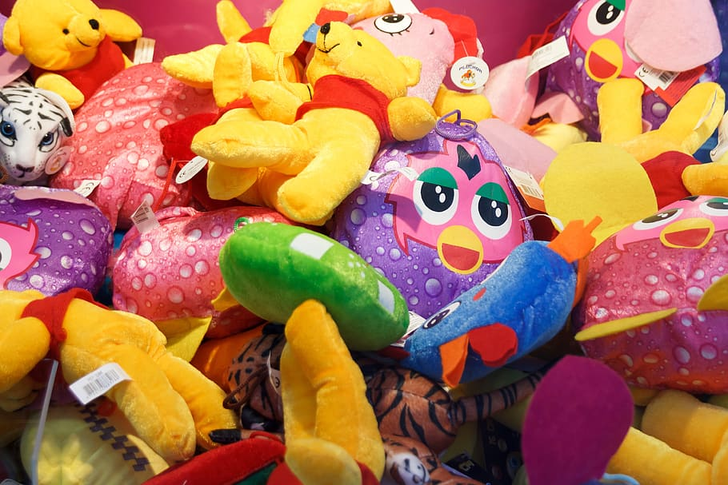 | Space  Compose pieces to represent space.  Use graphic notation.  Develop and refine instrument choices, pitch and dynamics  Perform to the class and evaluate performances | FUNS - Master dynamic balance (on a line) and counter balance (with a partner) skills considering 'social' objectives.  Games - Hockey - to apply skills needed in hockey (passing, defending and attacking) to impact competitive games. | Growing and changing  Puberty and hygiene  Feelings and emotions  Different families | This was taught last half term. | In the Town  We will be learning how to have a conversation about where we live, the buildings that are there.  Directions  We will learn how to use directions to explain the positioning of a place or item. | Do you have to believe in God to be human?

