Year 1 Spring Term - February - Our Learning
English | Maths
- Daily phonics lessons for all children, which includes reading (Sounds, words, sentences and books), writing and spelling.  - Class books: Burglar Bill and Perfectly Norman.  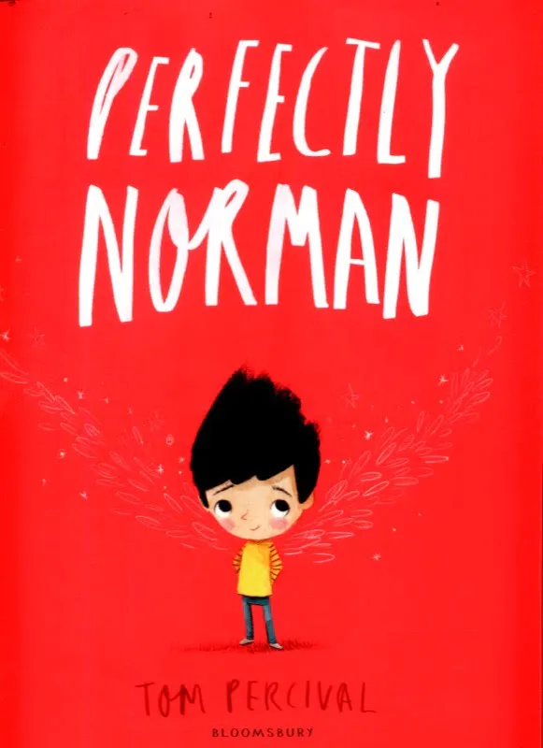  - Weekly activities across the curriculum will be inspired by our class books.  - Create my own sentence - build it in my  head, rehearse it, remember it and  write it using my phonics to help me spell.  - Use capital letters and full stops. | - Addition and Subtraction within 20 - using all our known number knowledge and facts.  - Shapes and patterns - 3D and 2D shapes.  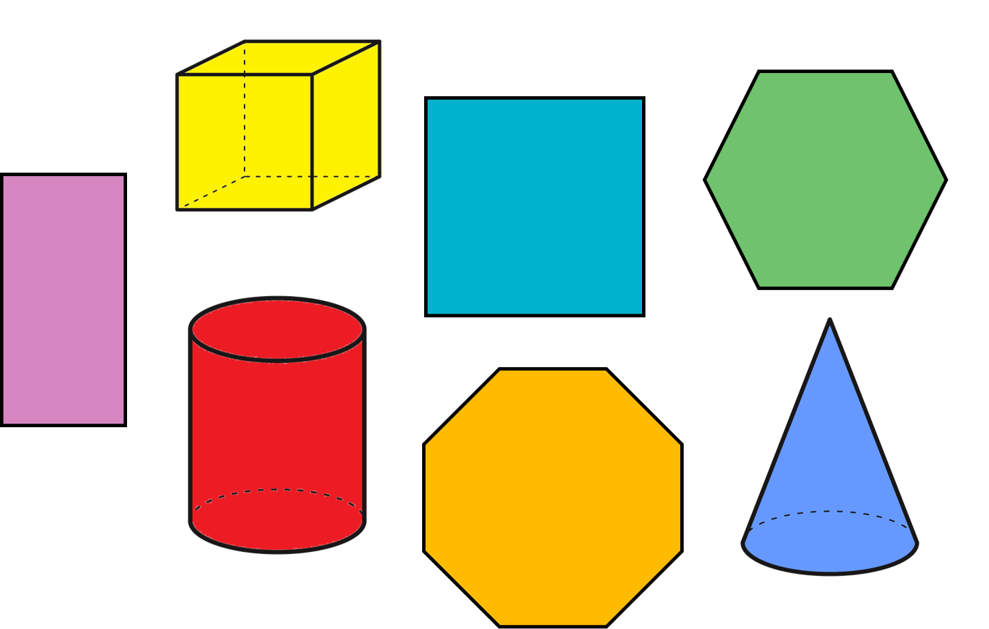  - Height and length - measuring using non-standard units (items and body parts) and a ruler.
How you can help at home: | How you can help at home:
- Read with your child every day. Your child can read their school reading book to you using their phonic skills to work out new words. Encourage them to read familiar words quickly and fluently, and chat about the story together to check understanding.  - Read aloud to your child using the library book sent home from school or any other books your child enjoys. There are lots of free ebooks online and membership of March library is free as well. | Practise maths skills through everyday tasks such as:  - Counting objects, including by grouping into 2s, 5s and 10s  - Money - recognising the value of each type of coin and counting up the value of a small pile of coins  - Using digital and analogue clocks to tell the time - o’clocks, half past, quarter to and quarter past  - Cooking or baking together - using scales to weight the ingredients  - Naming 2D and 3D shapes you can see in the world around you. Which ones are symmetrical?

Science | History | Geography | Art and Design | Design Technology | Music | P.E. | P.S.H.E. | Computing | R.E.
Investigating materials that float or sink  Testing transparency  Identifying and naming everyday materials  Naming different liquids | Looking at characteristics of toys from the past  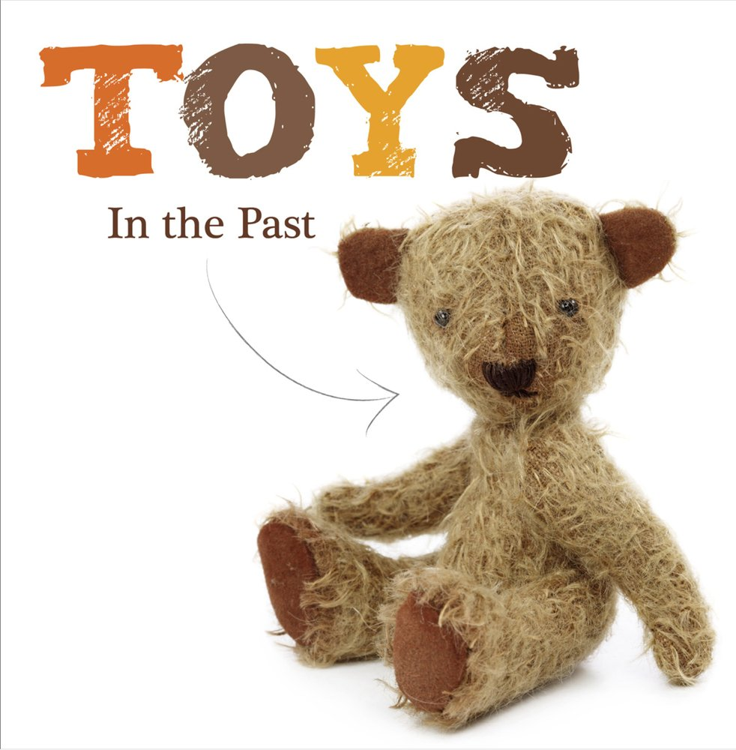  What is the same and what is different about old and new toys of similar types? | Identifying the countries that make up the UK  Exploring games from around the world including hop scotch, tag, keep the ball and jump rope | Making a clay teddy  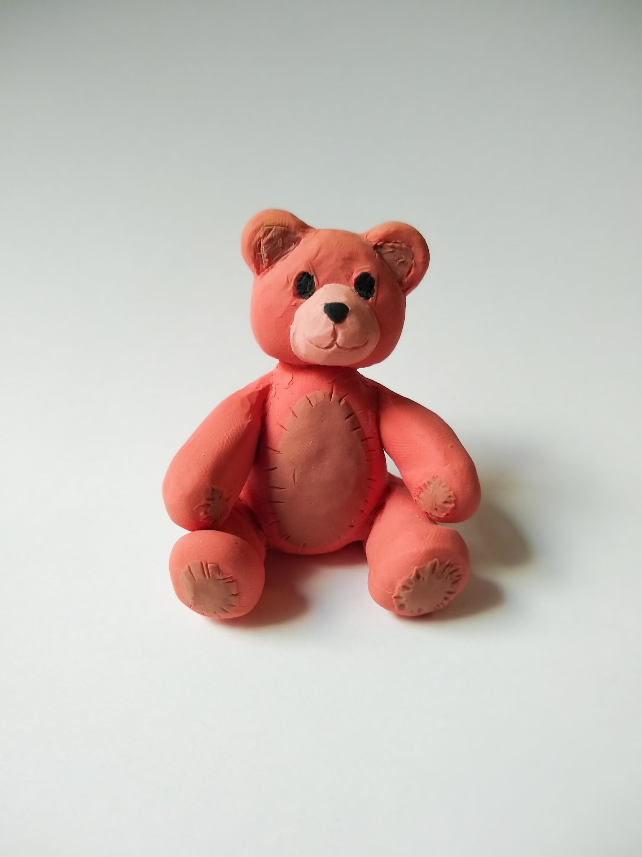 | Design technology will be covered in Spring 2 | Playing tuned and untuned instruments musically  To listen carefully and develop aural (listening) memory.  Rewrite the lyrics to the ‘Feather Theme Song’ from Forrest Gump. | Developing coordination through ball skills - sending and receiving  Exploring counter balance with a partner  Perform a sequence of movements with some changes in level, direction or speed | To understand what ‘my community’ means and the benefits of belonging to community groups  To begin to understand the role of the media in their local community | Introduction to animation  Using Scratch Jr and use commands to move a spirit  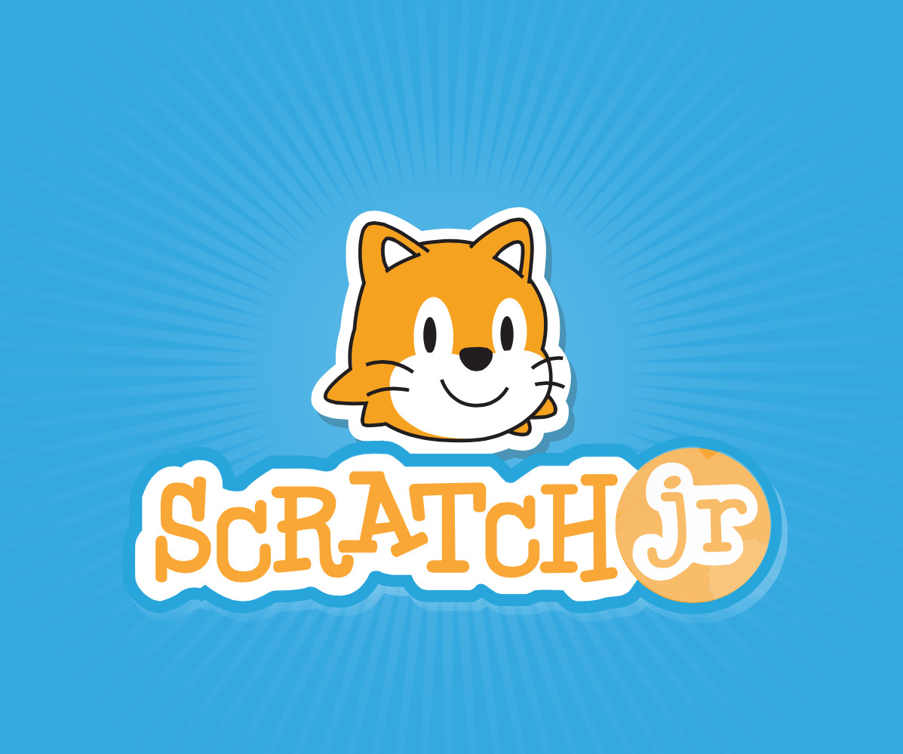 | Understanding why it is important to rest and have peace in the week  Exploring things Christians celebrate to show their faith in Jesus  Exploring special occasions - naming and baptism

