Year 2 Spring Term - January 2023 - Our Learning

English | Maths
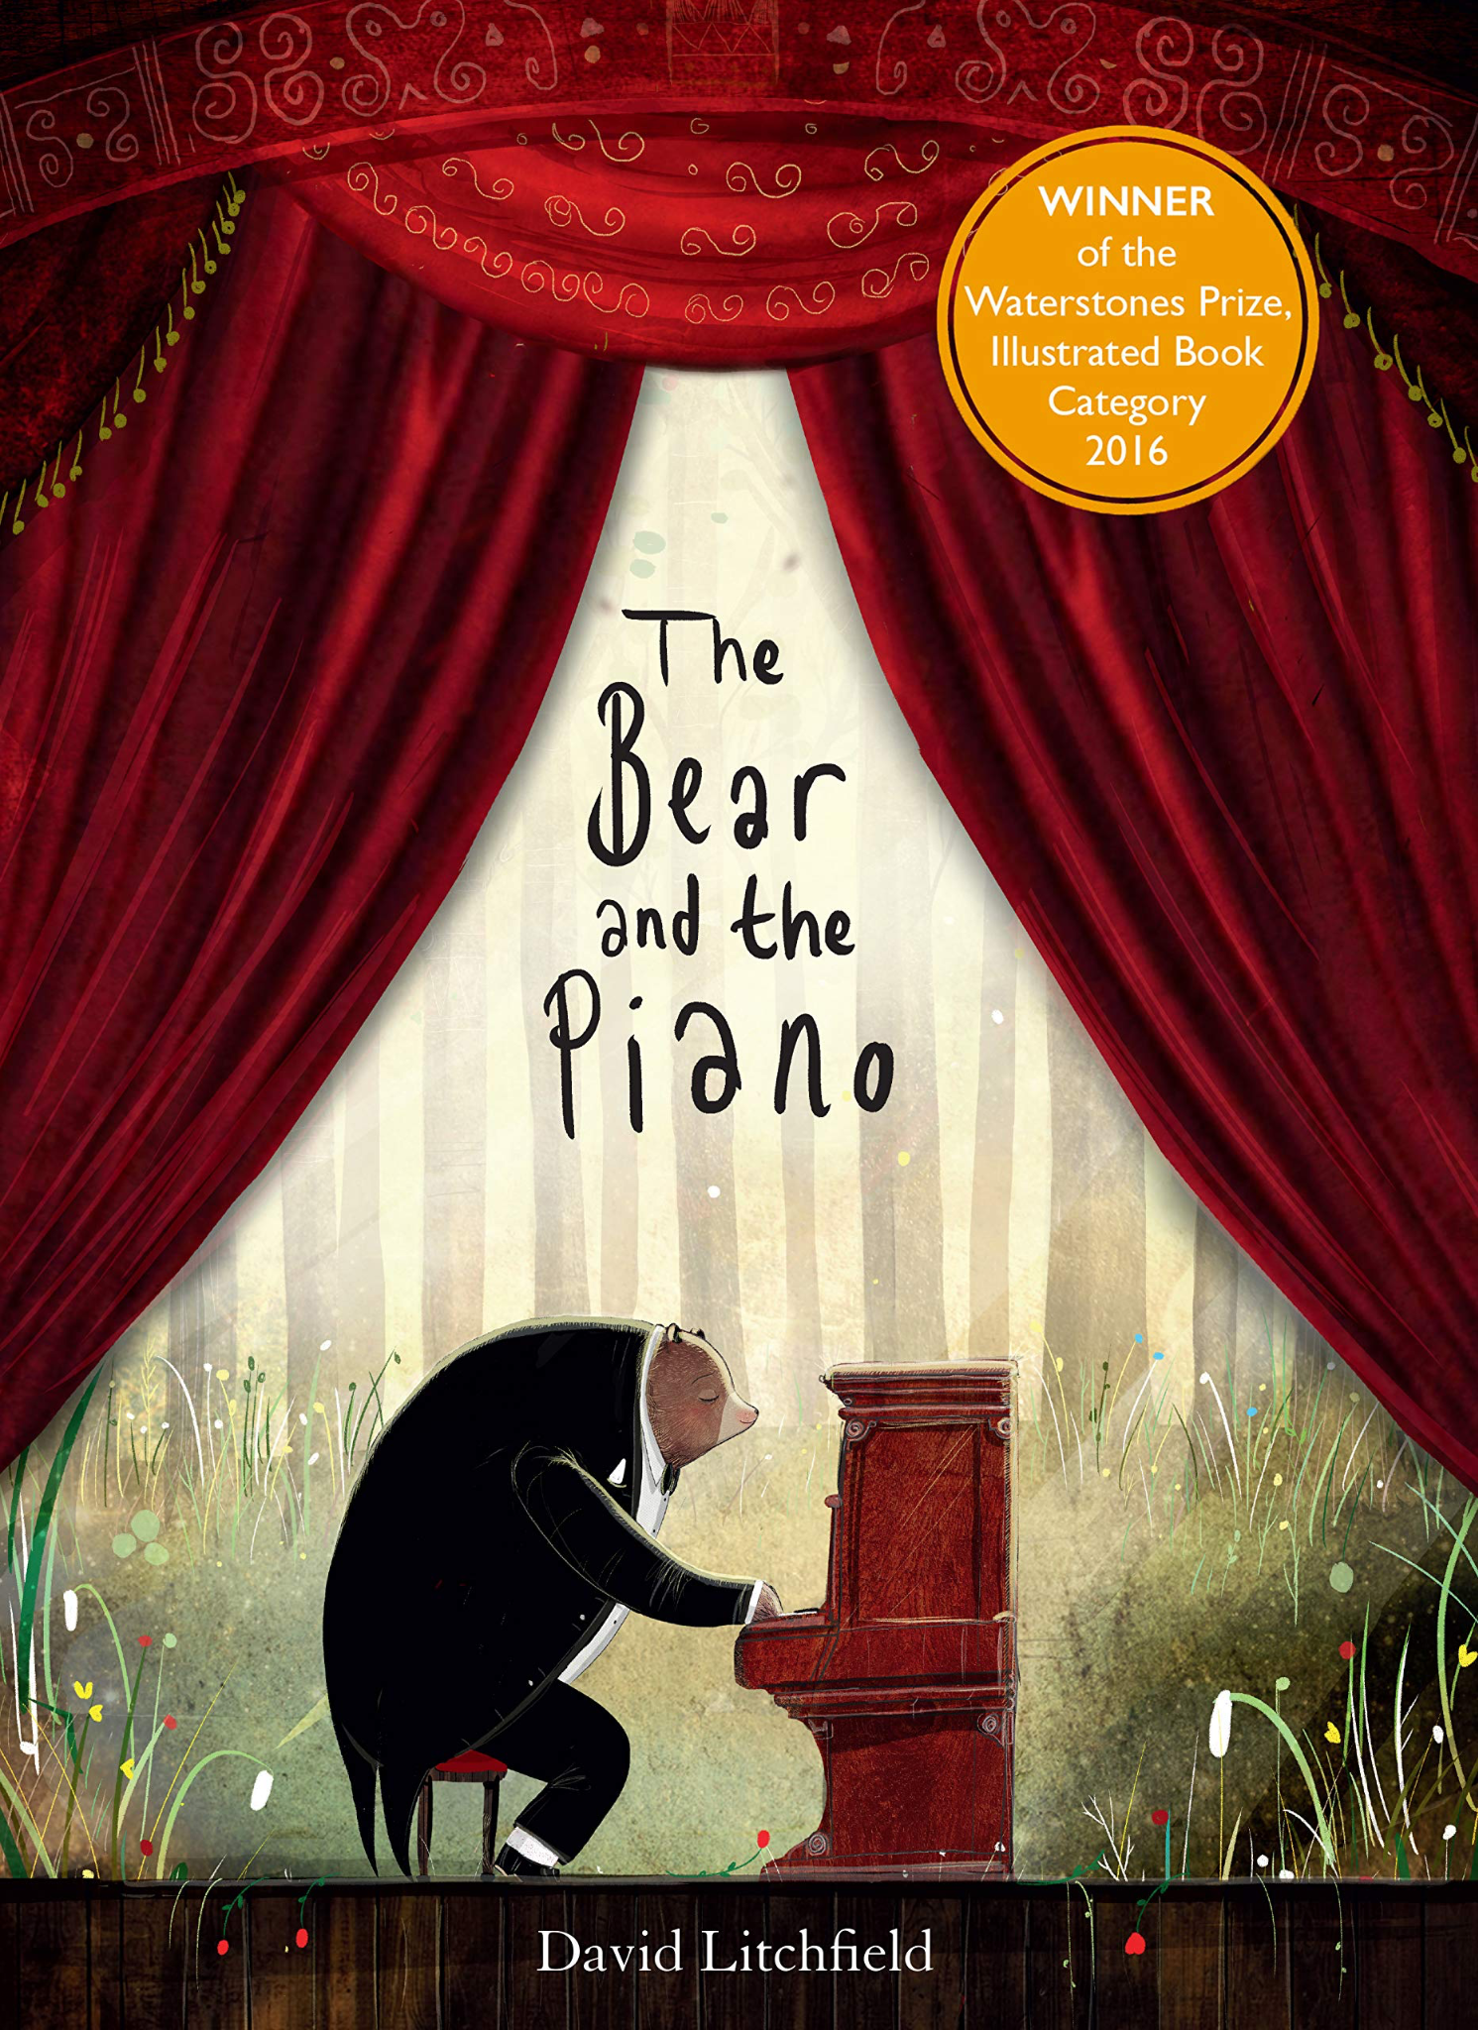  - Class text - The Bear and the Piano - we will be writing a balanced argument, deciding whether the bear should follow his dreams or stay with his friends.  - We will be writing a short recount about our Christmas holidays, using time connectives and expanded noun phrases to help us describe all of the exciting things we got up to.  - We will be continuing our weekly handwriting sessions and phonics lessons. | - Temperature - reading and estimating using degrees celsius.  - Pictograms - reading pictograms.  - Solving addition and subtraction word problems.  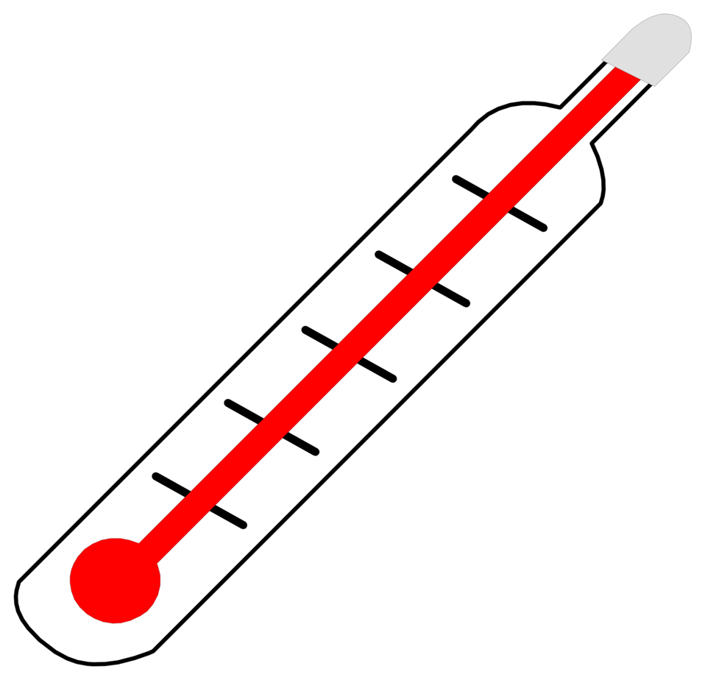
How you can help at home: | How you can help at home:
- Read with your child every day. Your child can read their school reading book to you using their phonic skills to work out new words. Encourage them to read familiar words quickly and fluently, and chat about the story together to check understanding.  - Read aloud to your child using the library book sent home from school or any other books your child enjoys. There are lots of free ebooks online and membership of March library is free as well. | Practise maths skills through everyday tasks such as:  - Counting objects, including by grouping into 2s, 5s and 10s  - Money - recognising the value of each type of coin and counting up the value of a small pile of coins  - Using digital and analogue clocks to tell the time - o’clocks, half past, quarter to and quarter past  - Cooking or baking together - using scales to weigh the ingredients  - Naming 2D and 3D shapes you can see in the world around you. Which ones are symmetrical?

Science | History | Geography | Art and Design | Design Technology | Music | P.E. | P.S.H.E. | Computing | R.E.
Life cycles of a plant:  What do they need to grow?  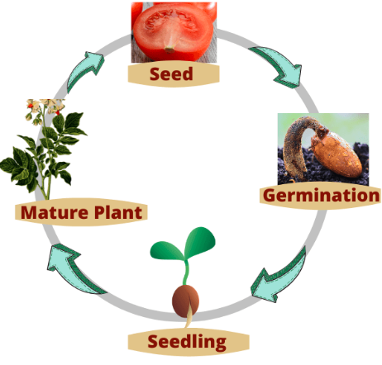 | Homes: How are modern homes different from the past?  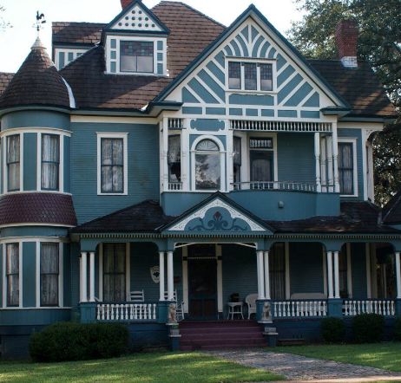 | Covered later in term. | Covered later in term. | Can you design a placemat to protect a table?  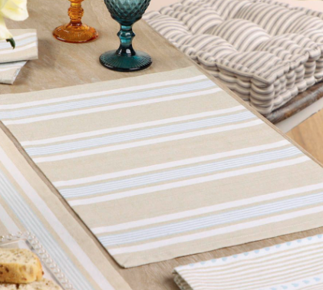 | Theatre Makers:  Recognising changes in sounds and instruments.  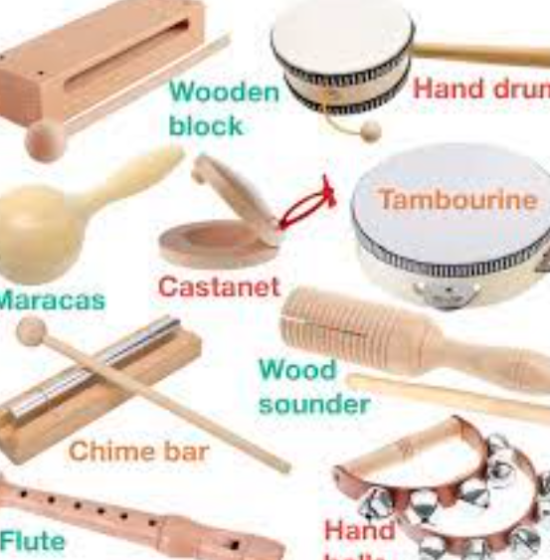 | Balancing and agility skills: Dynamic and static balances.  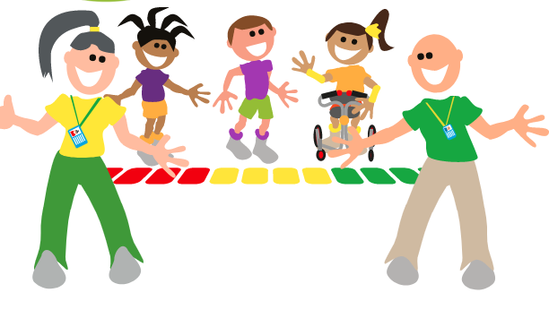 | Family and friends:  Who is special to me and why? How do they support me?  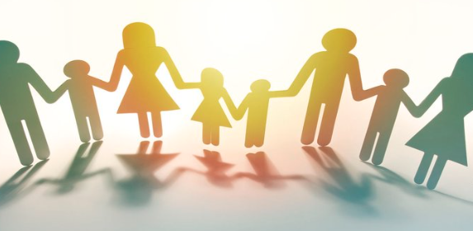 | Pictograms: Can you create a pictogram?  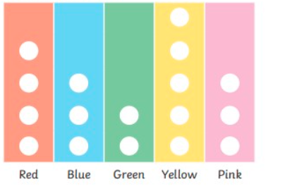 | Sikhism  What is Sikhism? What do Sikhs believe in?  