Year 5 Spring Term 1 - January and February 2024 - Our Learning Topic: Castles

English | Maths
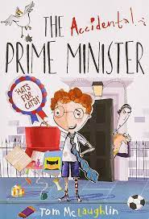  - Our text for the first half of the Spring Term is ‘The Accidental Prime Minister’ by Tom Mclaughlin.  - Inspired by The Week Junior’s Big Debate, we will be writing balanced arguments.  - We will also be exploring persuasive writing, including writing persuasive speeches.  - Grammar and punctuation: Children will learn about modal verbs, recapping relative clauses and using punctuation for parenthesis, as well as using their existing knowledge of grammar and punctuation. | - Graphs: reading tables and line graphs  - Fractions: comparing fractions, ordering fractions, adding and subtracting fractions and mixed number fractions.  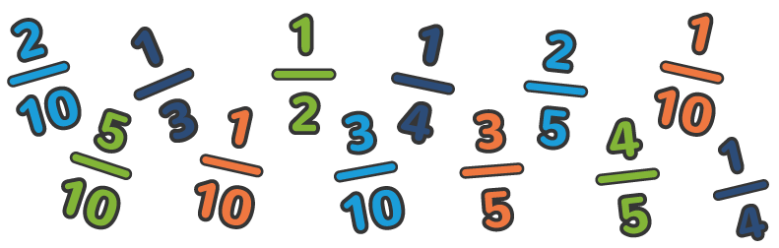
How you can help at home: | How you can help at home:
- Read with your child, even if they are a fluent and confident reader, asking comprehension questions; there are example questions to guide you in the Y5 google classroom  - Encourage your child to read independently for sustained periods  - Learn spellings and complete spelling homework task by Friday each week | - Practise rapid recall of times tables and linked division facts - you can use TTRockstars to support this.  - Practise recall of KIRFs, which this half term is conversions of measure.  - Use opportunities to tell the time in daily life  - You will find a summary of the written calculation methods we teach in school in the Y5 google classroom.  - Encourage your child to complete weekly homework task on SATs Companion

Science | History | Geography | Art and Design | Design Technology | Music | P.E | PSHE | Computing | Spanish | RE
Forces  Exploring gravity, resistance, friction and mechanisms  We will learn about different types of force and what effect they have on everyday objects.  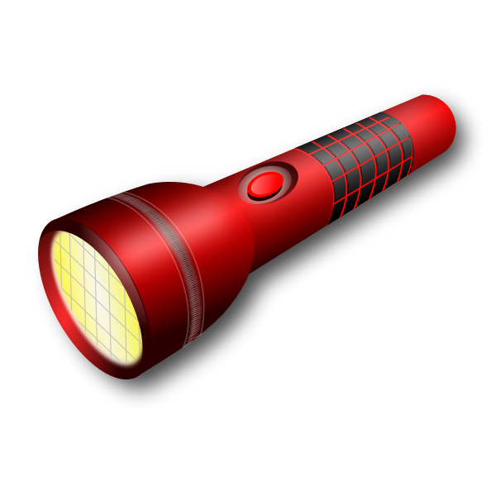 | Castles  This term we will learn;  Why, where and when castles were built.  How castles changed over time.  The inside of a castle.  What jobs people had in the castle.  Who lived in castles.  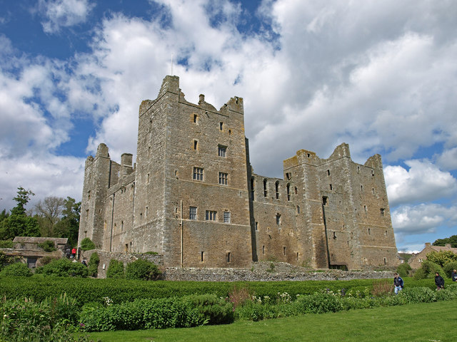 | Next half term | Castle painting  After studying two point perspective and the shapes of castles, we will create a painting of one. We will develop our colour mixing skills and practise using a fine brush.  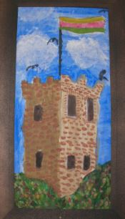 | Next half term | What is a chord?  How is music composed?  We will be learning how to sing and play different chords.  We will then compose and write our own music.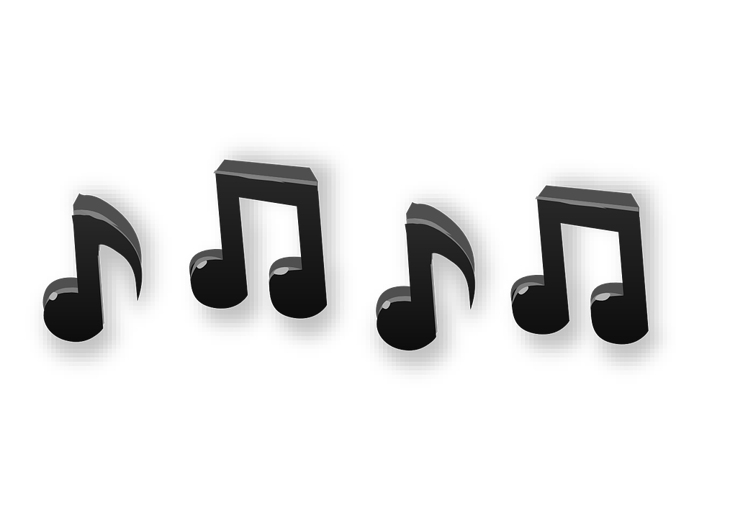 | Indoors: Dance  Outdoors: Netball  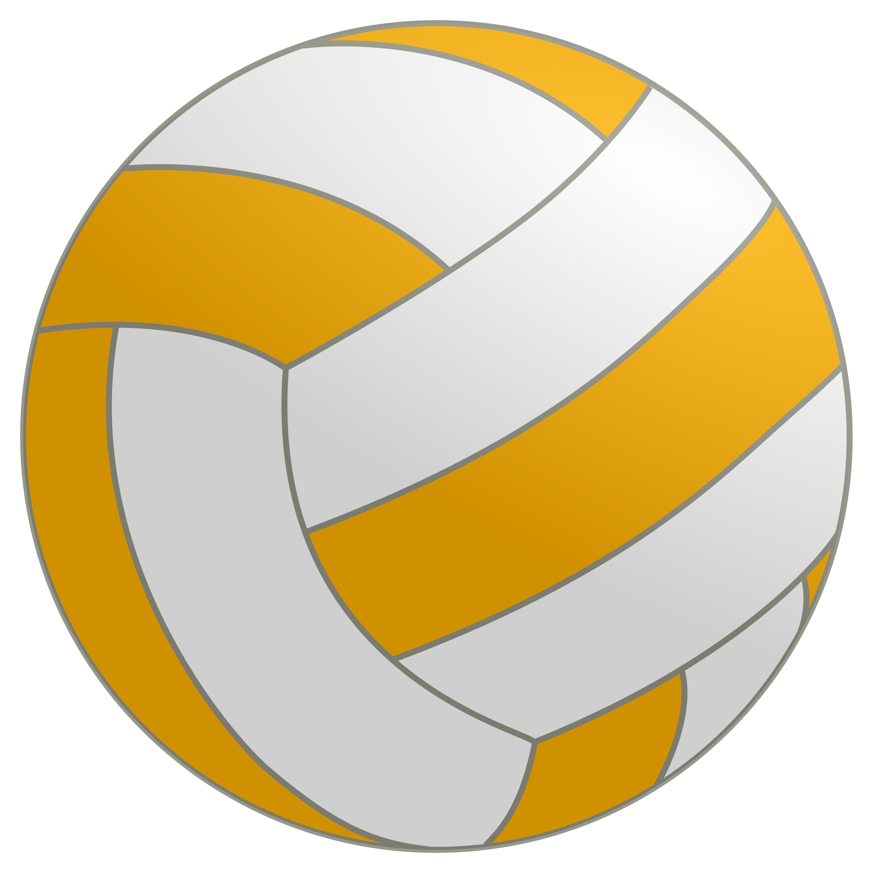 | Financial capability:  We will learn what happens to the money we earn and how to keep it safe.  Sex and relationship education: What happens as we grow up? Changes in puberty. | Video editing  We will learn what a video is, and how to plan, record, edit and finalise a video in groups. | Going to the doctor  Telling the time  Musical instruments  Measurements  We will be learning vocabulary related to each of the above topics, singular and plural nouns, masculine and feminine nouns, asking and answering questions.  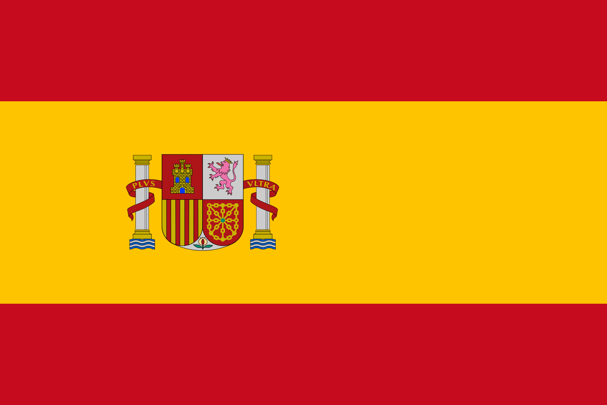 | Good or Evil?  We will explore the characteristics of good and evil and how people use religion to decide what’s right and wrong.  