Year 5 Spring Term A - Our Learning Topic: Castles

English | Maths
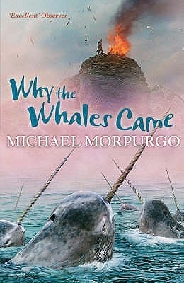  - Our text for the first half of the Spring Term is ‘Why the Whales Came’ by Michael Morpurgo  - Through this text, we will be creating our own non-chronological report.  - Punctuation and grammar focus: relative clauses, subordinate clauses, fronted adverbials, paragraph structure, headings and subheadings and parenthesis. | - Graphs: reading tables and line graphs  - Fractions: comparing fractions, ordering fractions, adding and subtracting fractions and mixed number fractions.  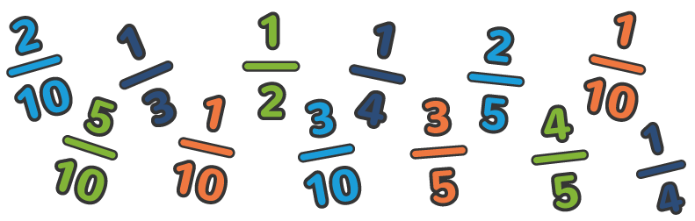
How you can help at home: | How you can help at home:
- Read with your child, even if they are a fluent and confident reader, asking comprehension questions; there are example questions to guide you in the Y5 google classroom  - Encourage your child to read independently for sustained periods  - Learn weekly spellings (these are set as homework in reading records) | - Encourage your child to complete weekly homework - TTRockstars tasks set weekly on Fridays  - Practise rapid recall of times tables and linked division facts  - Use opportunities to tell the time in daily life  - You will find a summary of the written calculation methods we teach in school in the Y5 google classroom.

Science | History | Geography | Art and Design | Design Technology | Music | P.E | PSHE | Computing | Spanish | RE
Light and Sight  How does light travel?  We will learn about the movement of light and how shadows are formed.  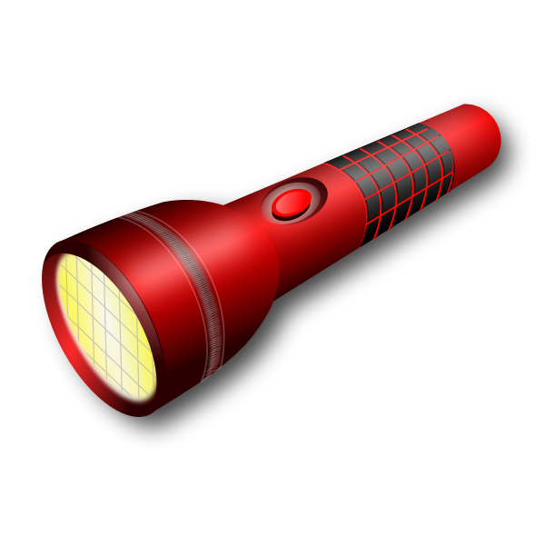 | Why were castles built?  What made a castle difficult to attack?  This term we will find out;  Why, where and when castles were built.  The inside of a castle  What jobs people had in the castle.  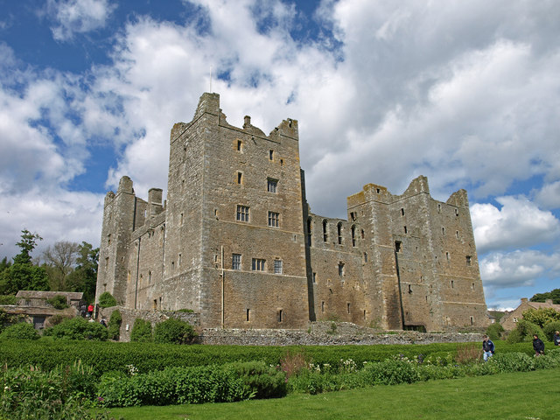 | Next half term | Castle painting  After studying the shapes of castles, we will create a painting of one. We will develop our colour mixing skills and practise using a fine brush.  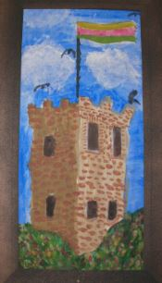 | Textiles: Combining different fabric shapes  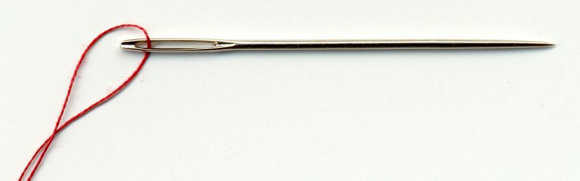  We will be learning how to sew together different fabrics to make a belt. | What is a chord?  How is music composed?  We will be learning how to sing and play different chords.  We will then compose and write our own music.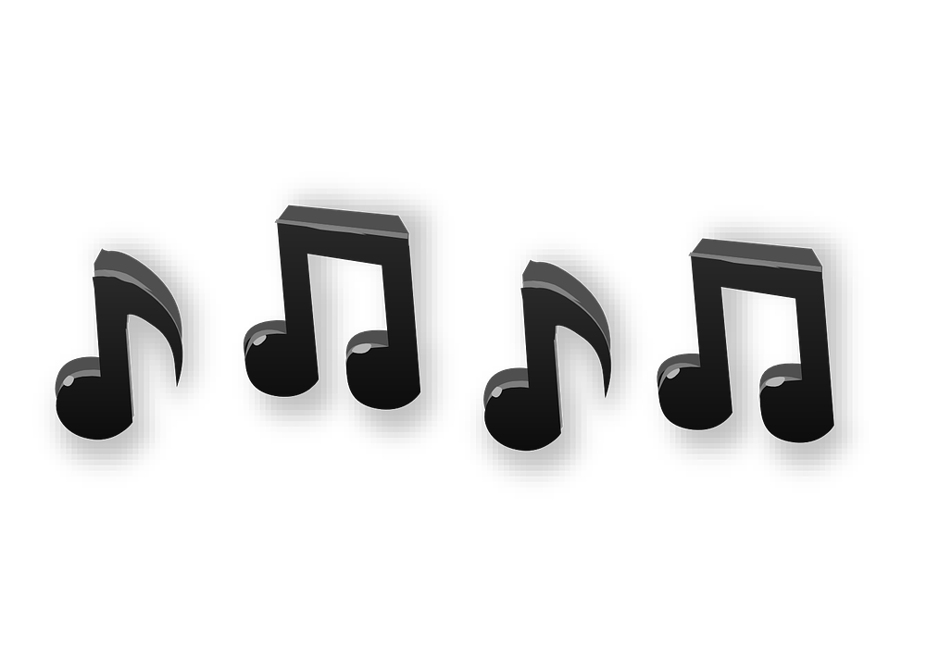 | Indoors: Dance  Outdoors: Netball  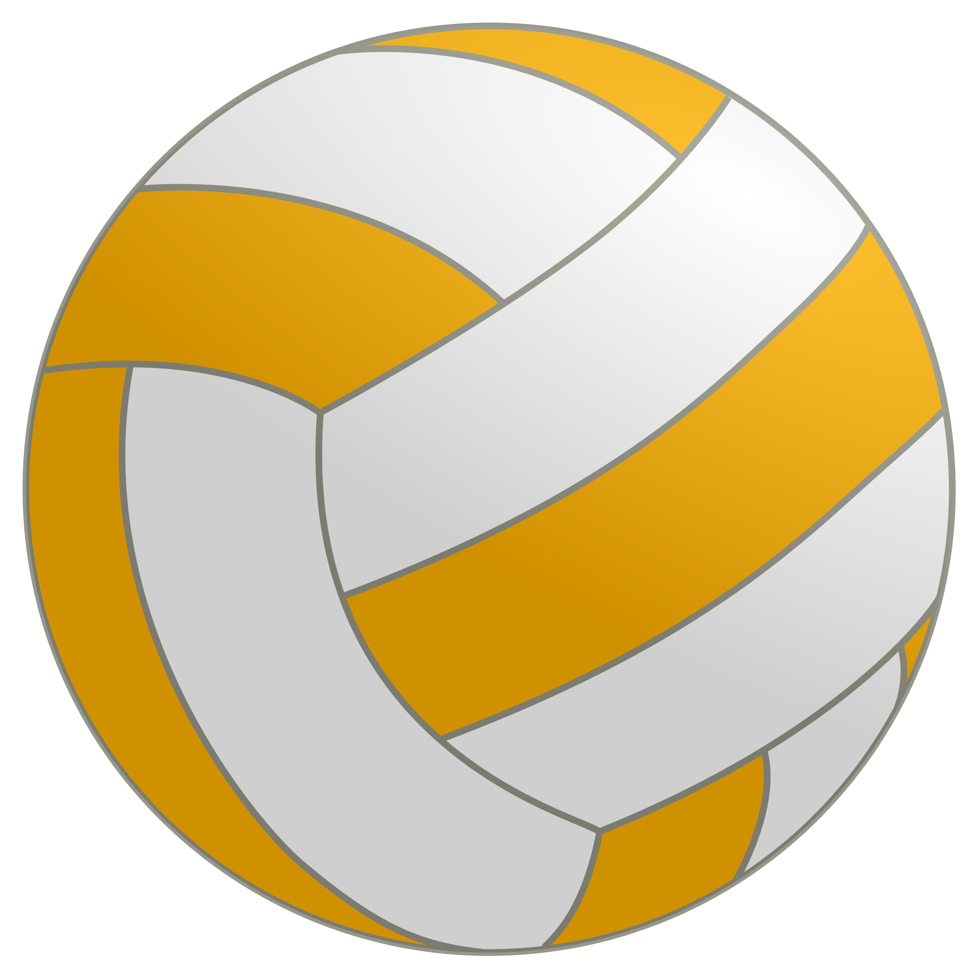 | Sex and relationship education: What happens as we grow up? Changes in puberty.  Financial capability: How do we keep our money safe? | Creating media vector drawings  We will learn what a vector is and how we can create a drawing using layers of vectors. | I like/ Do not like  Telling the Time  We will learn new vocabulary, as well as practising the spanish vocabulary we have already learnt.  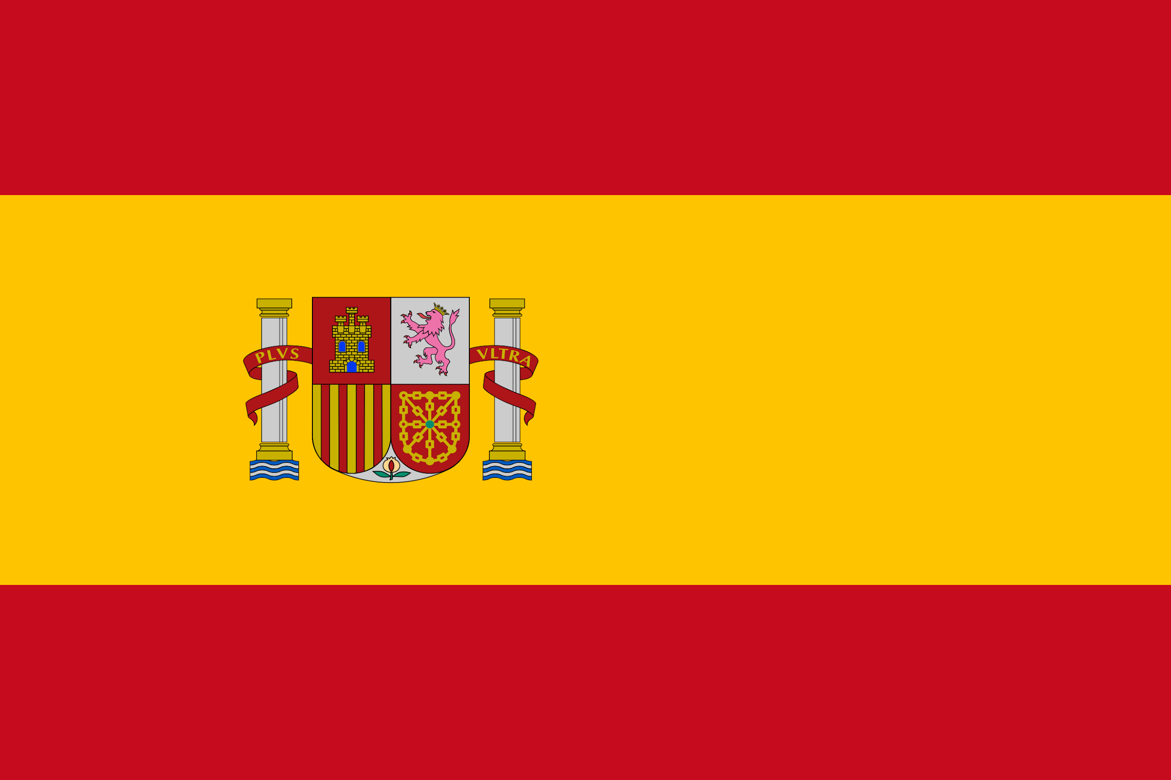 | Good or Evil?  We will explore how people use religion to decide what’s right and wrong.  